1. (a) Fig. 4.2 shows a flower of *Lilium polyphyllum*, a lily that grows in the Himalayan mountains. This species is cross-pollinated by insects.

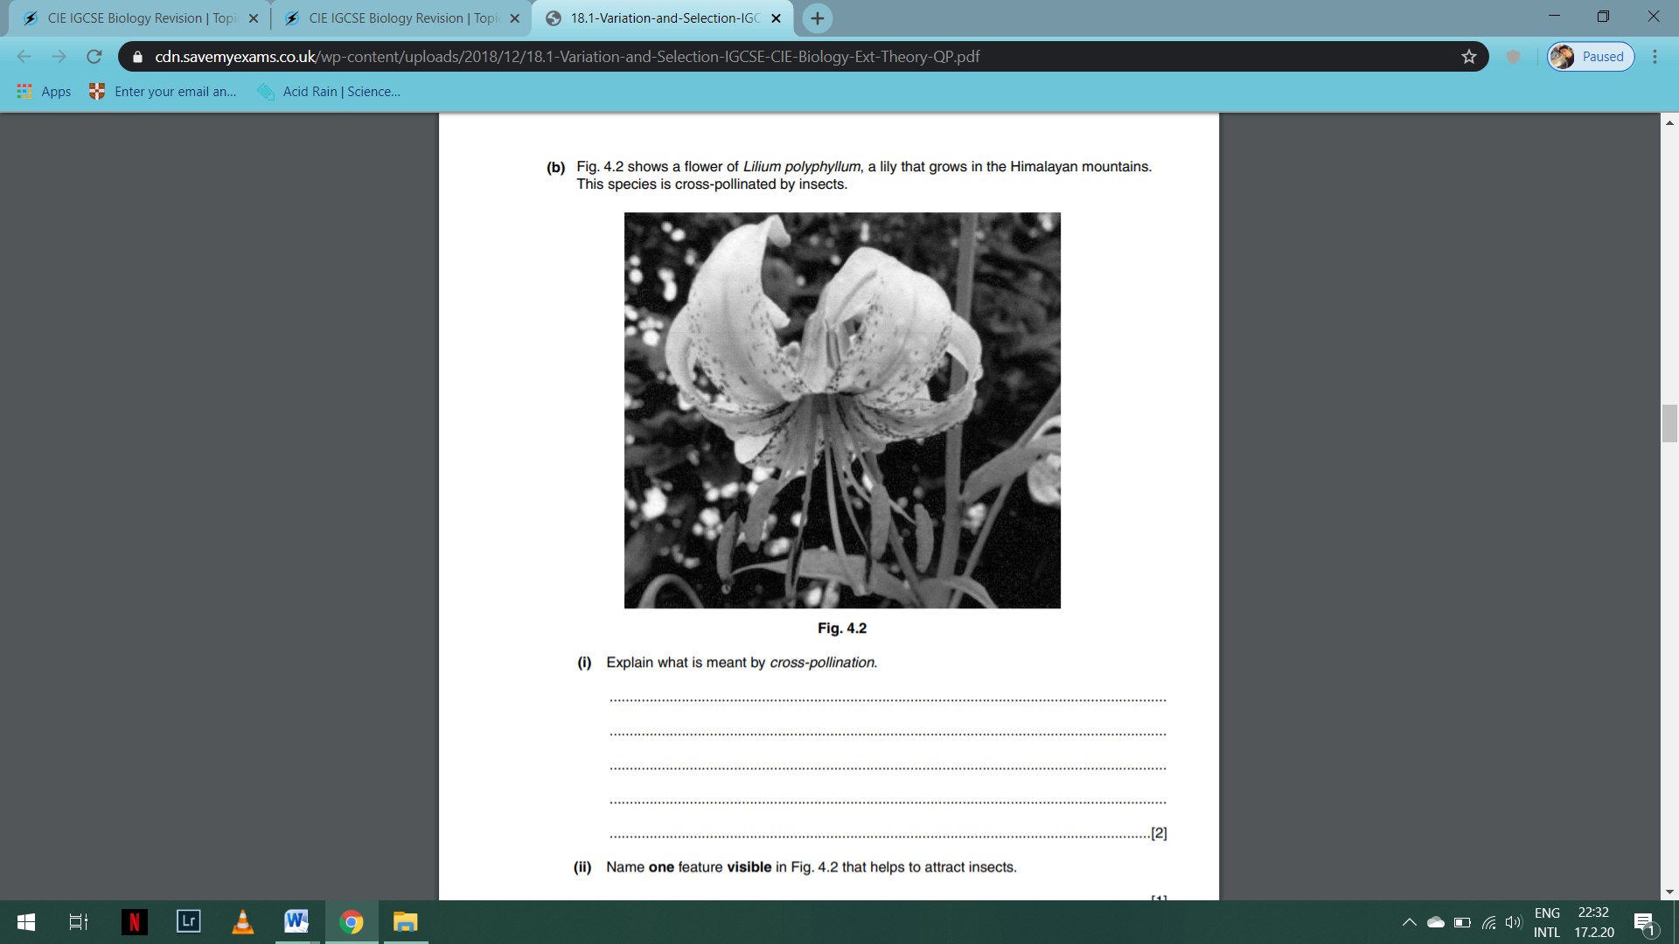

(i) Explain what is meant by cross-pollination.

................................................................................................................................................

................................................................................................................................................

……………………………………………………………………………………………………………………………………………

……………………………………………………………………………………………………………………………………………

[2]

(ii) Name one feature visible in Fig. 4.2 that helps to attract insects.

……………………………………………………………………………………………………………………………………….[1]

(b) Plants of this species that grow at low altitudes produce flowers 60 days before the plants of the same species that grow at high altitudes.

(i) Suggest one environmental reason why lilies that grow at lower altitudes flower earlier than the lilies at higher altitudes.

……………………………………………………………………………………………………………………………………….[1]

(ii) Explain why flowering time is an example of continuous variation.

................................................................................................................................................

................................................................................................................................................

……………………………………………………………………………………………………………………………………………

……………………………………………………………………………………………………………………………………………

[2]

(c) Scientist think that plants of L. *polyphyllum* growing at high altitudes may evolve into a new species/

Explain how natural selection could lead to the evolution of a new species of lily.

................................................................................................................................................

................................................................................................................................................

……………………………………………………………………………………………………………………………………………

……………………………………………………………………………………………………………………………………………

................................................................................................................................................

................................................................................................................................................

……………………………………………………………………………………………………………………………………………

……………………………………………………………………………………………………………………………………………

[4]