Light and Shadows (Hamilton)

Unit: Light and Shadow

**(Hamilton)**

a. What is light, properties of light?

b. Light sources and their effects on human eye

c. Reflective colours and materials

d. Reflection of light by different surfaces

e. Shadows.

**Understanding Light**:

* + Total darkness is the absence of light, leading to an inability to see.
  + Light travels faster than anything else in the universe, moving at a speed of 300,000,000 meters per second.
  + Light travels in straight lines.
  + Visible light is also known as white light and comprises seven different colors.

**Additional Topics Covered:**

1. **Reflective Colors and Materials**:
   * Exploring materials and colors that reflect light.
2. **Reflection of Light by Different Surfaces**:
   * Investigating how light bounces off various surfaces, leading to reflection.
3. **Shadows**:
   * Understanding how shadows are formed when objects block light.

**(Cambridge)**

3.1 – shadows

3.2 – Changing shadows

3.3 – Transparent Materials

3.4 – Translucent Material

**What is a Shadow?**

* A shadow is a dark shape that appears when an object blocks light. Think of it as a "copy" of the object on the ground or on another surface, but in dark form.
* Light can only travel in a straight line. A shadow is formed when something blocks light.

**Why is there a shadow?**

* Shadows are formed when an object blocks light, causing a darker area behind it.

**Mirrors**

* A smooth, shiny surface is very good at reflecting light.
* A mirror has a smooth, shiny surface.

**Image**

* When you see your face in a mirror you are seeing light from your face reflecting off the mirror.
* We call the reflection of your face in the mirror your image.

**Light Travel:**

* Light always travels in a **straight line**, moving from its source in a direct path.

**Shadow Formation:**

* When an object moves closer to the light source, its shadow **gets bigger**.

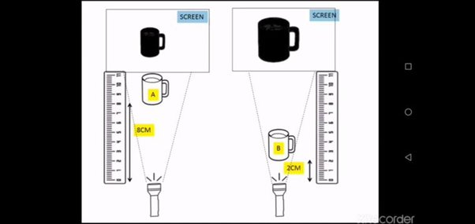

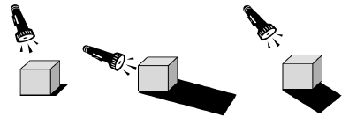

**Shadow Darkness:**

* The darkest shadow is produced when light shines on an **opaque object** like a wooden chopping board.

|  |  |  |
| --- | --- | --- |
| **Opaque** | **Transparent** | **Translucent** |
| Something that you can't see through at all.    It's like a solid wall; light doesn't pass through, and you can't see what's on the other side. | Something that you can see through completely.    It's like a clear window; light passes through, and you can see objects on the other side easily. | Something that lets some light through but not enough to see objects clearly on the other side.    It's like a frosted glass; you can see shapes and colours but not details. |

