**Plickers Questions**

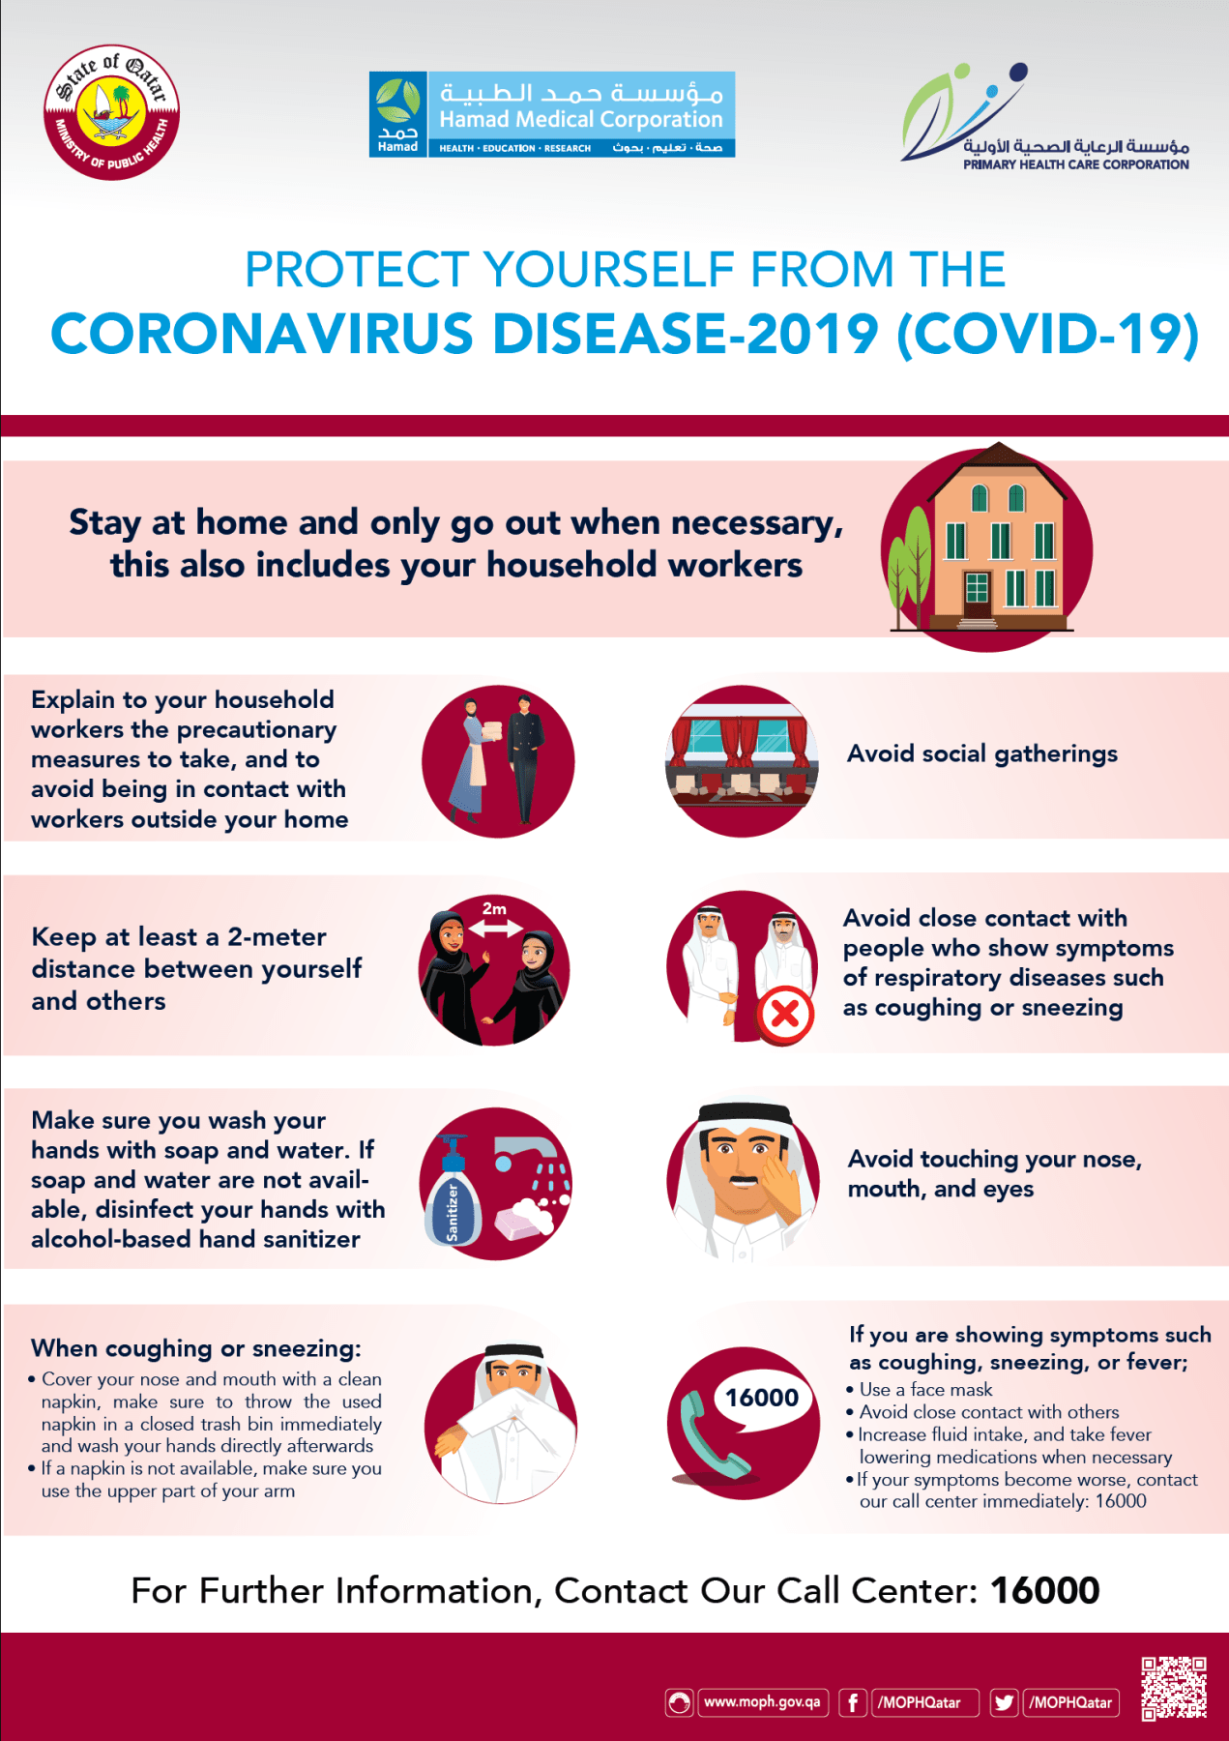Q1- Which is the correct word (verb) related to handwashing ?

1. Towel
2. Dry
3. Water
4. Soap

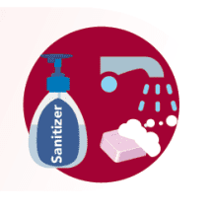Q2- Can you pick a proper instruction for the given picture?

1. Wash your hands with soap and water.
2. Do not wash your hands.
3. Use Sanitizers Only.
4. Wear a mask.

Q3- Which image instructs you to wear a mask?

 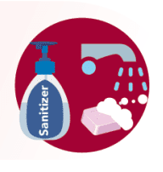 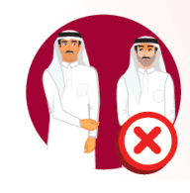 

Q4) Which is the correct adverb used for instruction text?

1. Second
2. Finally
3. Because
4. Justify