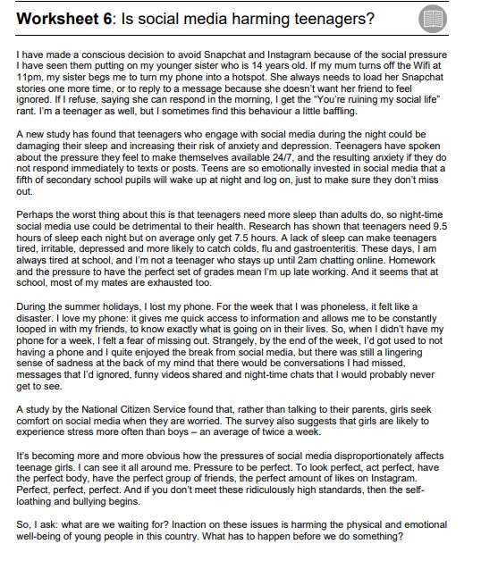

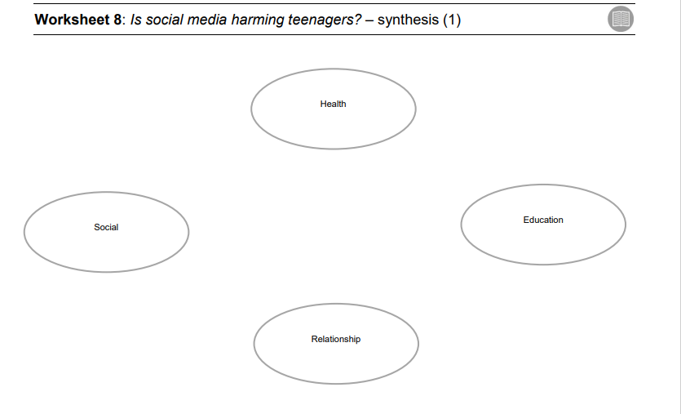

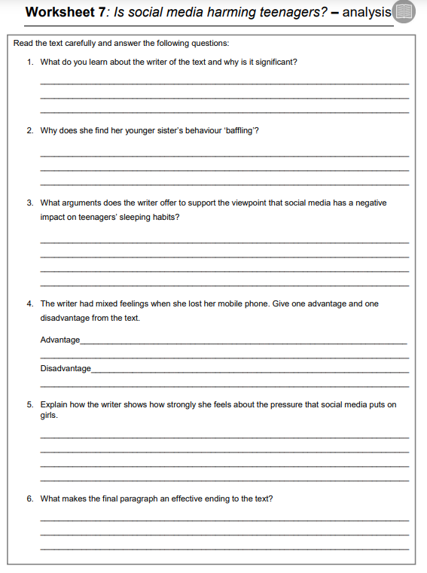

On the basis of your reading, write a speech to be given in the school assembly regarding the topic “Is Social Media Harming the teenagers”

In your talk you should:

* evaluate the views given in the texts about mobile phones
* give your own views, based on what you have read

Base your response on what you have read in the texts but be careful to use your own words.   
Write about 250 to 350 words.

Up to 15 marks are available for the content of your answer, and up to 25 marks for the  
quality of your writing.

…………………………………………………………………………………………………………………………………………………………………………………………………………………………………………………………………………………………………………………………………………………………………………………………………………………………………………………………………………………………………………………………………………………………………………………………………………………………………………………………………………………………………………………………………………………………………………………………………………………………………………………………………………………………………………………………………………………………………………………………………………………………………………………………………………………………………………………………………………………………………………………………………………………………………………………………………………………………………………………………………………………………………………………………………………………………………………………………………………………………………………………………………………………………………………………………………………………………………………………………………………………………………………………………………………………………………………………………………………………………………………………………………………………………………………………………………………………………………………………………………………………………………………………………………………………………………………………………………………………………………………………………………………………………………………………………………………………………………………………………………………………………………………………………………………………………………………………………………………………………………………………………………………………………………………………………………………………………………………………………………………………………………………………………………………………………………………………………………………………………………………………………………………………………………………………………………………………………………………………………………………………………………………………………………………………………………………………………………………………………………………………………………………………………………………………………………………………………………………………………………………………………………………………………………………………………………………………………………………………………………………………………………………………………………………………………………………………………………………………………………………………………………………………………………………………………………………………………………………………………………………………………………………………………………………………………………………………………………………………………………………………………………………………………………………………………………………………………………………………………………………………………………………………………………………………………………………………………………………………………………………………………………………………………………………………………………………………………………………………………………………………………………………………………………………………………………………………………………………………………………………………………………………………………………………………………………………………………………………………………………………………………………………………………………………………………………………………………………………………………………………………………………………………………………………………………………………………………………………………………………………………………………………………………………………………………………………………………………………………………………………………

………………………………………………………………………………………………………………………………………………………………………………………………………………………………………………………………………………………………………………………………………………………………………………………………………………………………………………………………………………………………………………………………………………………………………………………………………………………………………………….………………………………………………………………………………………………………………………………………………………………………………………………………………………………………………………………………………………………………………………………………………………………………………………………………………………………………………………………………………………………………………………………………………………………………………………………………………………………………………………………………………………………………………………………………………………………………………………………………………………………………………………………………………………………………………………………………………………………………………………………………………………………………………………………………………………………………………………………………………………………………………………………………………………………………………………………………………………………………………………………………………………………………………………………………………………………………………………………………………………………………………………………………………………………………………………………………………………………………………………………………………………………………………………………………………………………………………………………………………………………………………………………………………………………………………………………………………………………………………………………………………………………………………………………………………………………………………………………………………………………………………………………………………………………………………………………………………………………………………………………………………

**[Total: 40]**