Quiz 2 - MS
WEB DEVELOPMENT LAYERS
Question | Answer | Marks
1 | 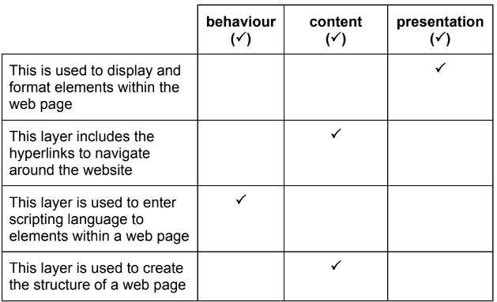 | 4
2 A  B | 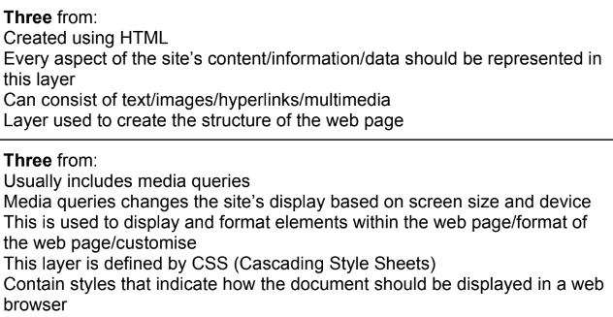 | 3  3

