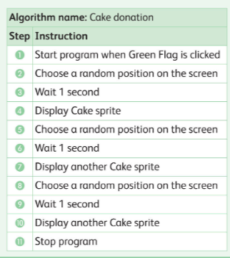
- Your school is having a charity cake sale and wants to show how many cakes have been baked.
a. Look at the algorithm below.
b. Rewrite the algorithm so that it is shorter
c. Create a scratch programme from your rewritten algorithm using the repeat block.
d. If 25 people bake cakes, how would your algorithm change?

