Exit Ticket
Shown below is a rectangle drawn on a coordinate grid.
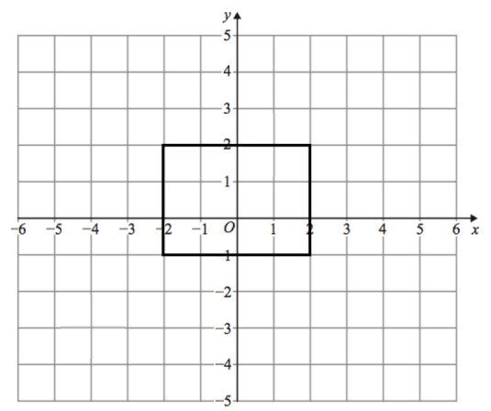
Enlarge the rectangle by scale factor 2, using centre of enlargement (−1, 0)

