Exercise 12.4

- The diagram shows a triangle on a coordinate grid. Draw an enlargement of the triangle with scale factor 3, centre (−2, 0).
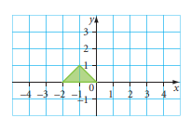

- The diagram shows a shape on a coordinate grid.

- On the first grid , draw an enlargement of the shape with scale factor 2, centre (2, 2).
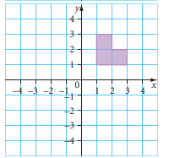

- On the second Grid, draw an enlargement of the shape with scale factor 3, centre (3, 3).

- On the third copy, draw an enlargement of the shape with scale factor 2, centre (3, 4).

- The diagram shows three triangles, A, B and C, on a coordinate grid.
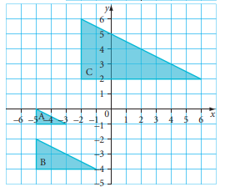

- Triangle B is an enlargement of triangle A. Describe the enlargement.

- Triangle C is an enlargement of triangle A. Describe the enlargement.

