**WORKSHEET**

1. Create the below webpage **CSSimplified.HTM** using **Notepad** as Editor and save it in your work area. This file should have all the basic structural tags of HTML.
2. Format the page as follows

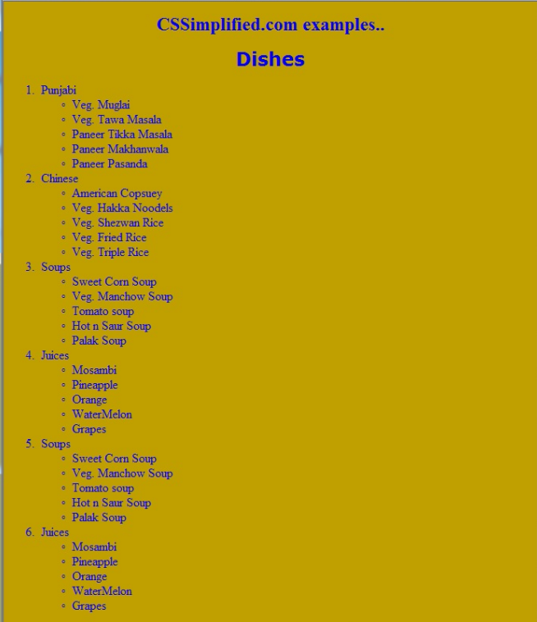

* Set the font of the title to **Times New Roman** and size to **5 pixel.**
* Set the font of subtitle to **verdana** and size to **5 pixel**