**Task A: Creating a Game in ScratchJr [15]**

**Steps:**

1. Create the Program: /1

- Open ScratchJr on your device.

- Create a new project.

2. Select the Cat Walking Character: /1

- Tap on the "Add" button at the bottom of the screen.

- Choose the "Character" tab.

- Scroll through the characters and select the Cat Walking character.

3. Add code to the Cat Walking Character: /2



4. Test the Code: /2

- Click on the purple message block to test the code.

5. Identify the error in the move right block: /2

- Examine the move right block and identify any errors.

6. Add the Soccer Ball and Code: /2

- Tap on the "Add" button.

- Choose the "Character" tab.

- Select the **Soccer Ball character**.

- Add code to the Soccer Ball character according to the provided algorithm. /2

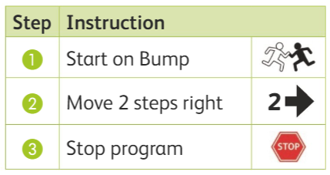

Here is the code for this algorithm

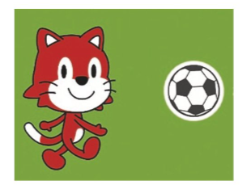 

7. Test Your Program. /3

- Observe the behavior of the Cat Walking and Soccer Ball characters.

- Determine if the program produces the desired result.

- Identify any errors and make necessary adjustments.

|  |  |  |  |
| --- | --- | --- | --- |
| **Rubric for ScratchJr** | | | |
|  | 1 | 2 | 3 |
| Open project |  |  |  |
| Able to use basic block |  |  |  |
| Able to add the characters |  |  |  |
| Able to find the error and Run the code |  |  |  |
| **Key**:   1. Needs more opportunity to develop this skill. 2. Beginning to demonstrate this skill. 3. Has achieved this skill. | | | |