The Haber process

**1** Consider the diagram of the Haber process below. Assign the labels below the diagram to the positions **A–F**.

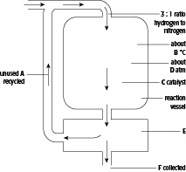

**200   450   condenser   hydrogen and nitrogen   iron   liquid ammonia**

**A** = ………………………………………… **B**  = …………………………………………

**C** = ………………………………………… **D** = …………………………………………

**E** = ………………………………………… **F**   = ………………………………………… [4]

**2** The graph shows how changing conditions of temperature and pressure affect the yield of ammonia in the Haber process.

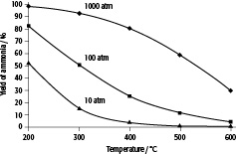

**a** What is the yield of ammonia at 300 °C and at:

**i** 10 atm pressure?

………………………………………………………………………………………………………………....

**ii** 100 atm pressure?

………………………………………………………………………………………………………………....

**iii** 1000 atm pressure?

………………………………………………………………………………………………………………....

**b** Which conditions seem to give the best yield of ammonia?

………………………………………………………………………………………………………………............

**c** Why are these not the normal operating conditions for the Haber process in industry?

………………………………………………………………………………………………………………............

………………………………………………………………………………………………………………............

**d** What is the % yield of ammonia likely to be at the normal operating conditions of 450 °C and 200 atm and why are these conditions used?

………………………………………………………………………………………………………………............

………………………………………………………………………………………………………………............

**TOTAL: _____/10**