**Unit 4. Be an animator**

**Task :**

1. Open a new project.

2. Add any Background.

3. Add the Cat character.

4. Add the code with the Repeat block.





5. Run your code. Do you get the correct results?

6. Add the Dog character.

7. Create a program for the Dog that uses the Repeat block to

match the algorithm below.

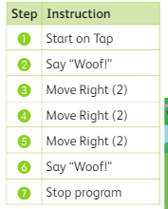

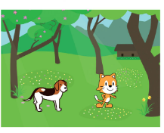

8. Run your completed program.