**Practical**

Spreadsheet are capable of holding a lot of data .Calculation can be performed and charts can be created from the data stored. It’s important to be able to select the correct data for these tasks. Look at the example below:

Data must be selected to:

1. Produce a column chart to show the **Item Name** and **Quantity Sold**. /2
2. Calculate the Total Quantity of **Items sold** for **Butter**, **Cheese**, and **Milk**. /3
3. Make a **line chart** of selected table /2
4. Find the difference between the **Unit Cost of Flour** and **Milk**. /2
5. Save a file with suitable name. /1

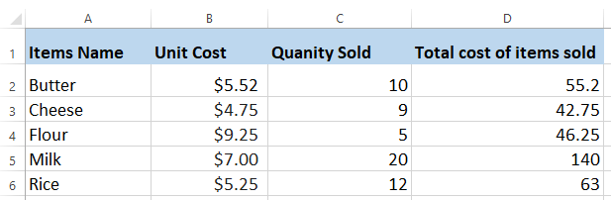

|  |  |  |  |  |
| --- | --- | --- | --- | --- |
| **Rubric for Spreadsheet** | | | | |
|  | 1 | 2 | 3 | Total |
| Able to enter data |  |  |  |  |
| Able to use find feature |  |  |  |  |
| Able to identify cell address |  |  |  |  |
| **Key**: 1. Needs more opportunity to develop this skill.  2. Beginning to demonstrate this skill.  3. Has achieved this skill. | | | | |