**FF-1**

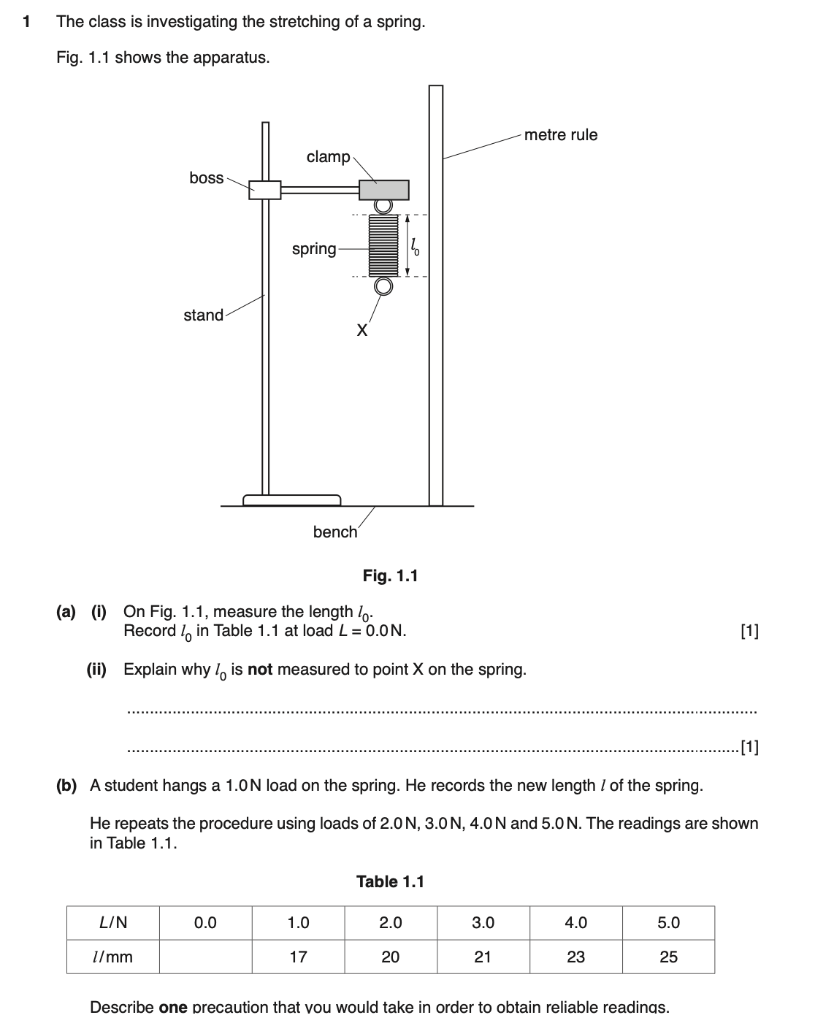

**…………………………………………………………………………………………………………………………………………………[1]**

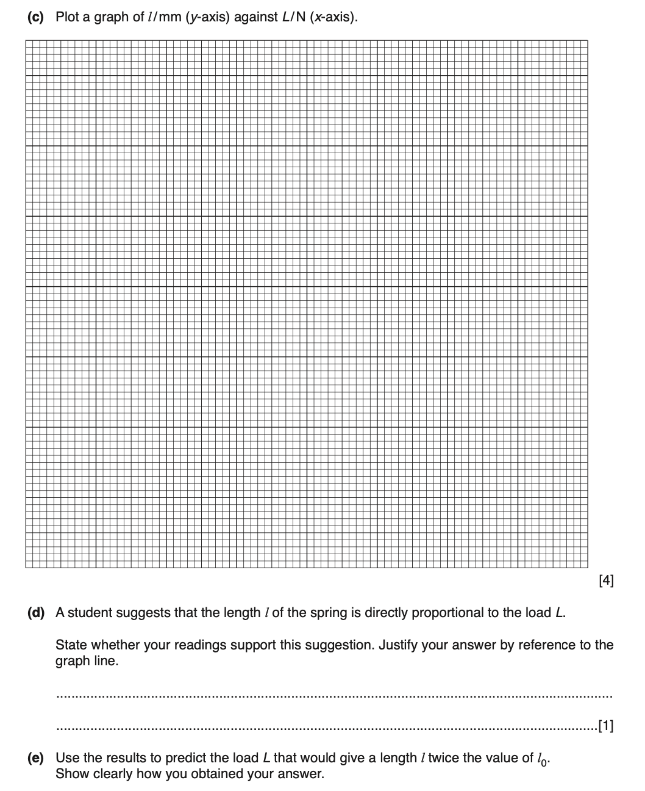

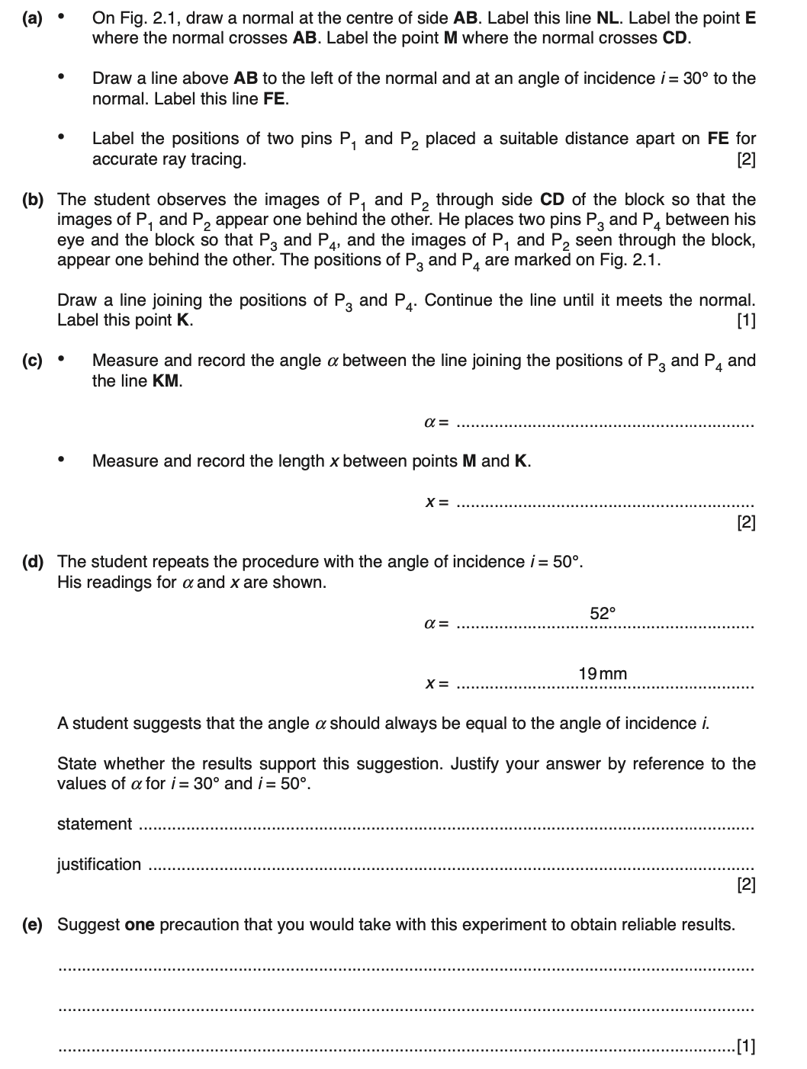 **[TOTAL :8]**