**The Baby’s Bedroom**

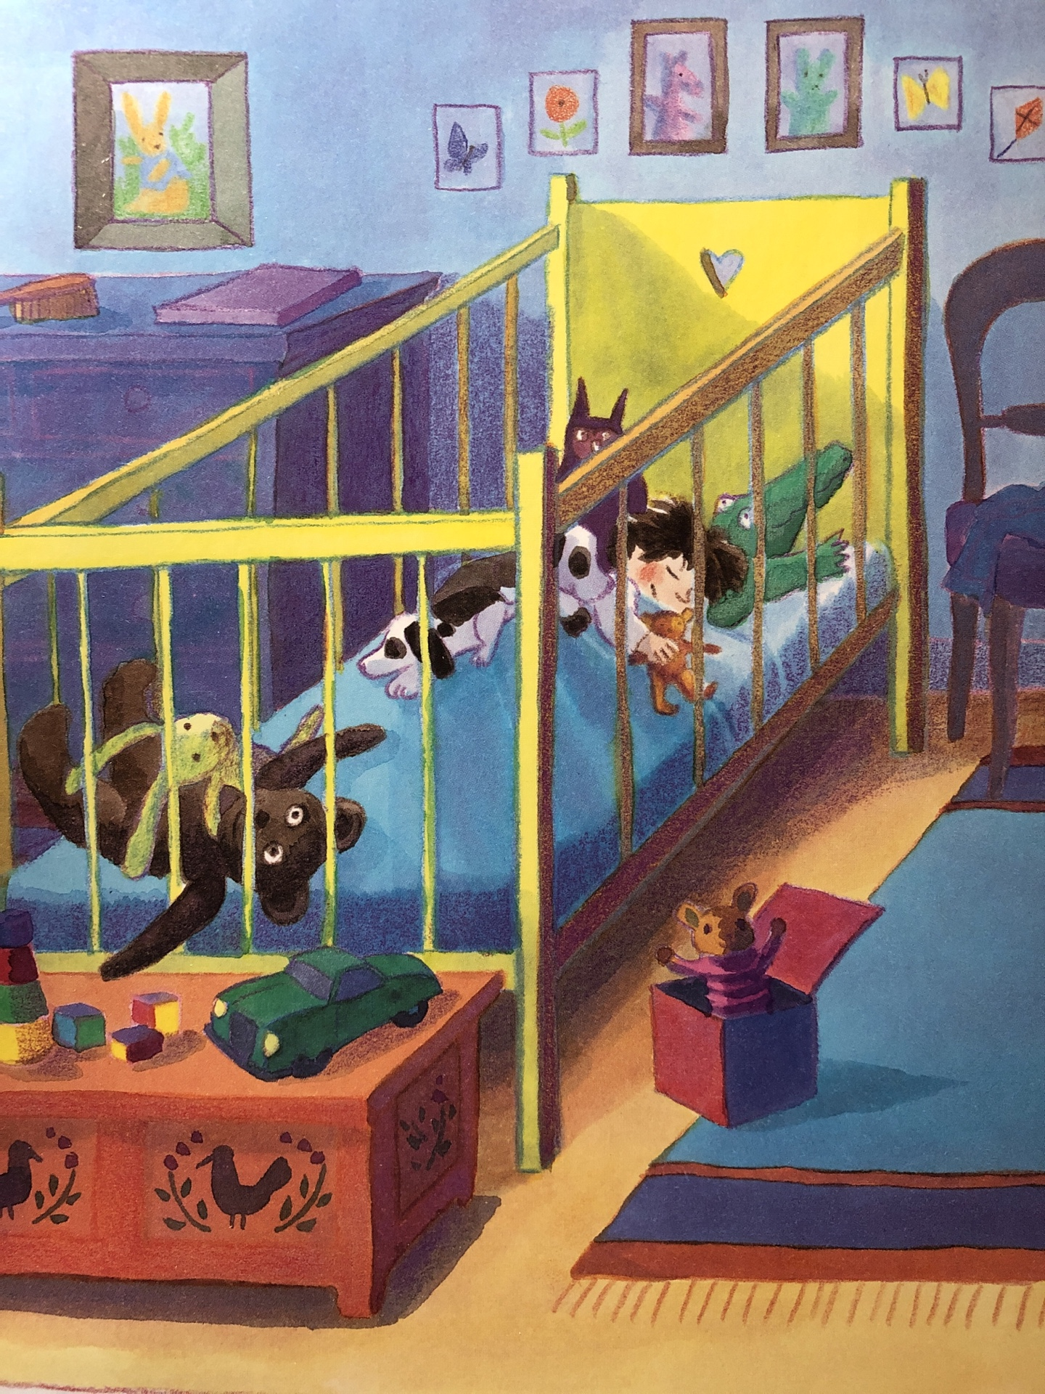

The baby’s bedroom is brightly painted and it is cosy. There are pictures on the wall and there is a towel on his chair. There are lots of toys in his cot but he seems to be fast asleep. If he wakes up, the toys might help him to sleep again. He is holding the tiny teddy that was given to Lily by Amelia. He might be thinking about the toys or he might be dreaming about playing with his green car. The brush and bottles are kept too high for him to reach because they might be dangerous. When he wakes up, he will probably want to get out of his bed to play straight away.

*Unit 2 Day 3*

**The Baby’s Bedroom – Conjunctions marked**

**

The baby’s bedroom is brightly painted and it is cosy. There are pictures on the wall and there is a towel on his chair. There are lots of toys in his cot but he seems to be fast asleep. If he wakes up, the toys might help him to sleep again. He is holding the tiny teddy that was given to Lily by Amelia. He might be thinking about the toys or he might be dreaming about playing with his green car. The brush and bottles are kept too high for him to reach because they might be dangerous. When he wakes up, he will probably want to get out of his bed to play straight away.

*Unit 2 Day 3*

**Conjunction List**

or

and

but

if

when

because

that

*Unit 2 Day 3*