1. Circle two items which are used as internal hardware devices. [2]

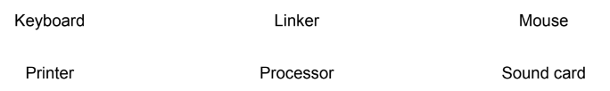

1. Tick whether the following statements are true or false. [4]

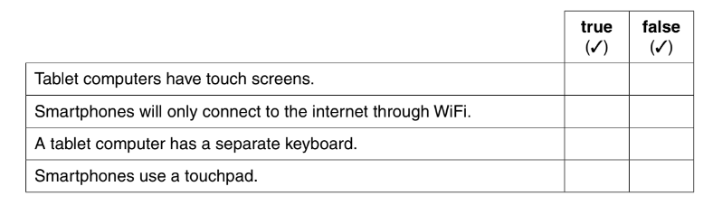

1. The Central Processing Unit consists of three components.

Tick (**√**) whether the following statements refer to the ALU, the Control unit or the Main memory. [4]

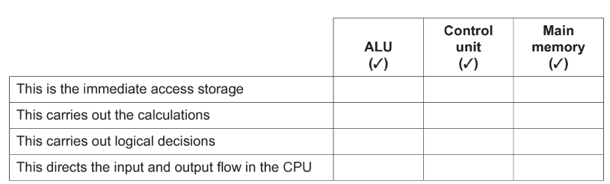

1. A desktop computer consists of both hardware and software. The software is either applications software or system software.
2. Tick (**√**) whether the following are examples of applications software or system software. [2]

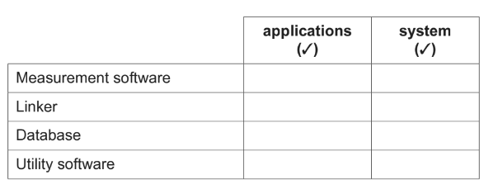

1. Describe the differences between using a Graphical User Interface (GUI) and a Command Line

Interface (CLI). [4]

……………………………………………………………………………………………………………………………………………………………………………………………………………………………………………………………………………………………………………………………………………………………………………………………………………………………………………………………………………………………………………………………………………………………………………….

……………………………………………………………………………………………………………….

……………………………………………………………………………………………………………….

……………………………………………………………………………………………………………….

1. People are buying smartphones rather than desktop computers.

Describe the differences between using a smartphone compared to a desktop computer. [4]

…………………………………………………………………………………………………………………………………………………………………………………………………………………………………………………………………………………………………………………………………………………………………………………………………………………………………………………………………………………………………………………………………………………………………………………………………………………...…………………………………………………………………………………………………………………………………………………………………………………………………………………………………………………………………………………………………………

……………………………………………………………………………………………………………….

……………………………………………………………………………………………………………….