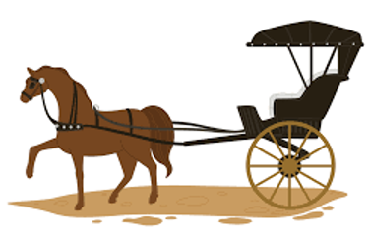Plickers

1. The horse is ________ carriage.
2. Push,
3. pull.
4. both
5. none of the above

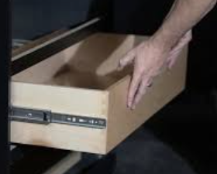

1. The drawer is being ___________ to close.
2. Pushed
3. Pulled
4. Both
5. None of the above
6. 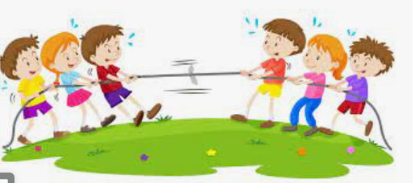Both the teams are ______
7. Pulling
8. Pusing
9. None
10. Both
11. Which among the following is showing both push and pull.
12. 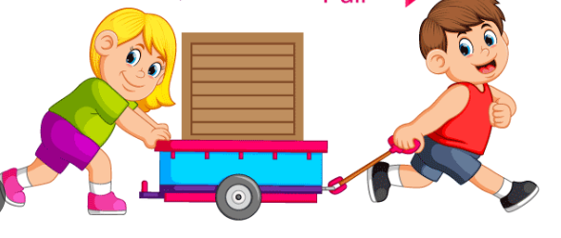
13. 

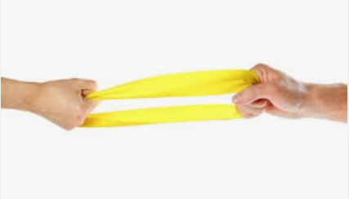

1. None of the above