**Bird Images**

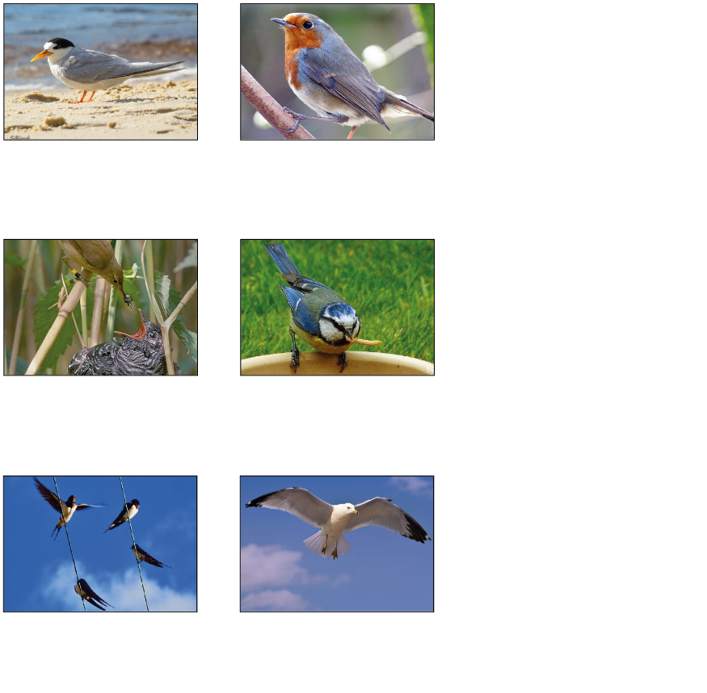

Unit 2 Day 3 and 4

Cuckoo & Reed

warbler

Seagull

Swallows

Blue tit

Fairy tern

Robin

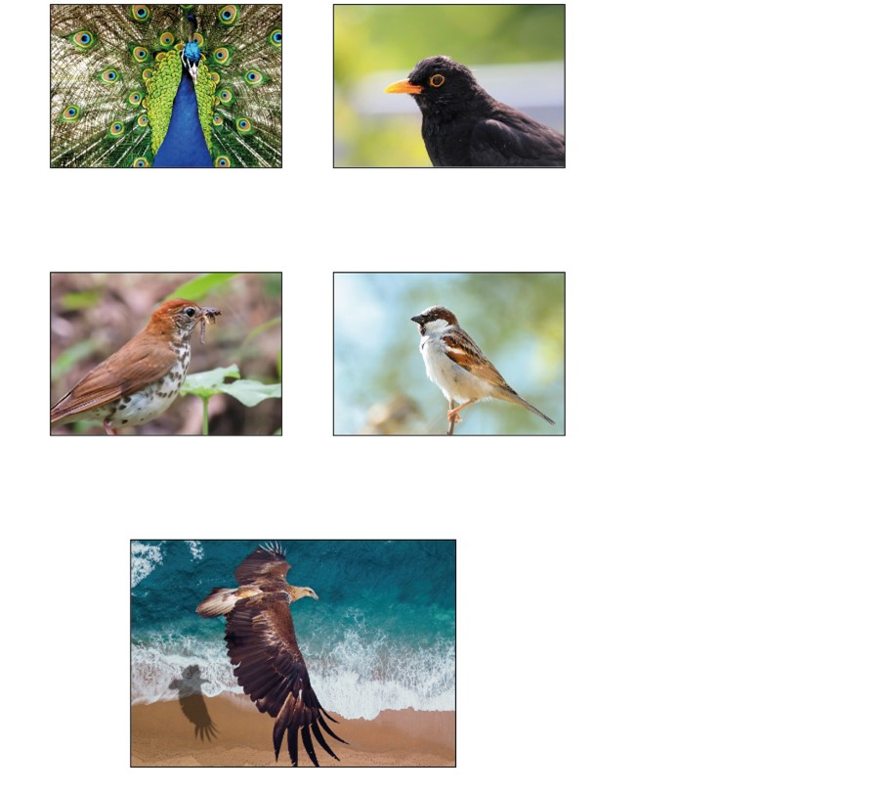

Unit 2 Day 3

Golden eagle

Sparrow

Thrush

Peacock

Blackbird

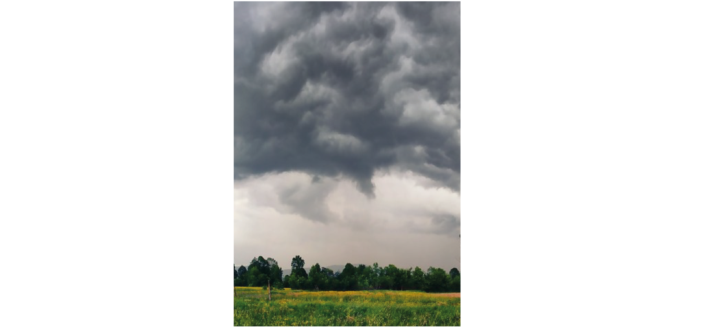Weather Words

|  |  |
| --- | --- |
| **wintery weather** | **snow and sleet** |
| **blustery wind** | **driving rain** |
| **summer sunshine** | **fluffy clouds** |
| **gentle drizzle** |  |

Unit 2 Day 3

**Haiku Template**

_____________

____________________________

_____________

Unit 2 Day 4