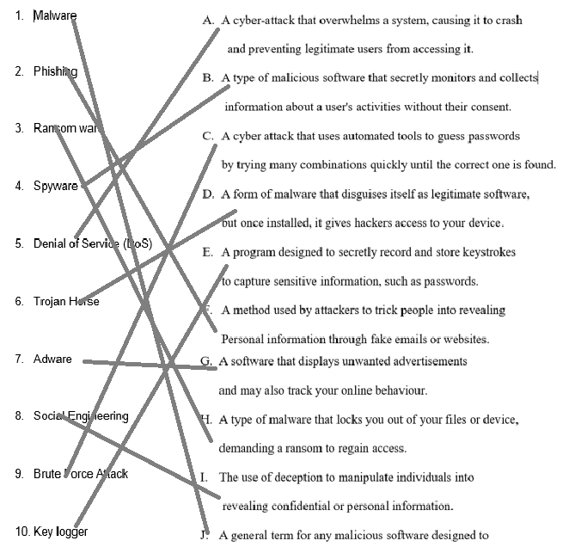 [5]

1. (a) Any two from:

− Encryption

− Biometric device

− Firewall

− Anti-spyware

− Two-factor authentication // two-step verification [2]

(b)To disrupt the operation of a web server/network [1]

3(a) − To obtain a user’s personal data [1]

3(b) Any two from:

− Hacking // Cracking

− Virus

− Spyware

− Malware [1]