1.Cyber security Threats: Match with correct definition

1. 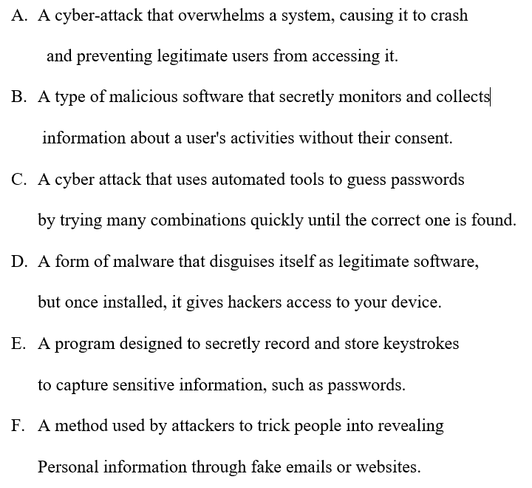Malware
2. Phishing
3. Ransom ware
4. Spyware
5. Denial of Service (DoS)
6. Trojan Horse
7. 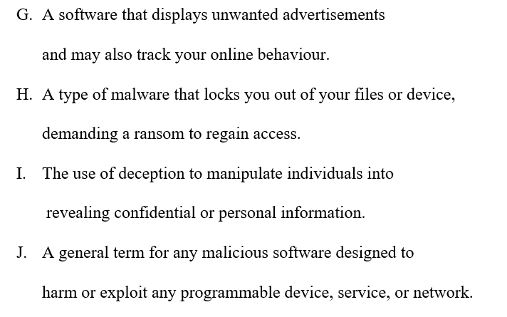Adware
8. Social Engineering
9. Brute Force Attack
10. Key logger

2. Tamaz stores confidential data on his computer. He uses the Internet regularly and is concerned about his data being viewed by unauthorized people. He currently has one software method to stop his data being viewed, which is a password.

He wants to add other software methods to stop his data being viewed by unauthorized people.

(a) State two other software methods that Tamaz could use to stop his data being viewed by

unauthorized people.

1 ...............................................................................................................................................

2............................................................................................................................................... [2]

(b) A denial of service (DoS) attack is a type of Internet security risk.

State the purpose of a denial of service attack.

..................................................................................................................................................

............................................................................................................................................ [1]

3(a) Phishing and pharming are also types of Internet security risk. They have the same purpose.

State the purpose of phishing and pharming.

..................................................................................................................................................

............................................................................................................................................ [1]

3(b) Identify two other types of Internet security risk.

1...............................................................................................................................................

2 ............................................................................................................................................... [1]