"Imagine you have some farms as follows . How many square meters is this equivalent to?"

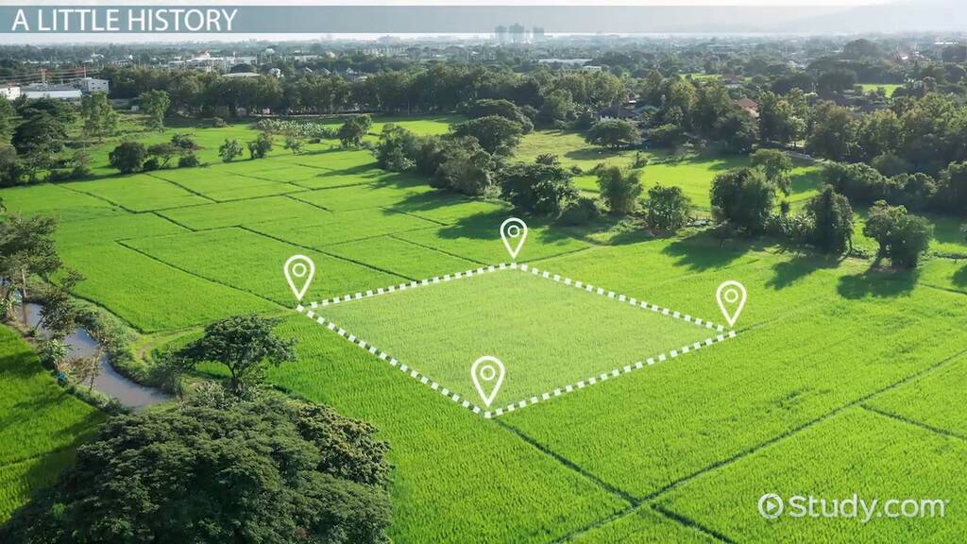**2.5 hectares**

