**Safety and Security**

[2]

1. Indicate, by ticking (✓) the appropriate box, which of the following are examples of a health risk and which are examples of a safety risk.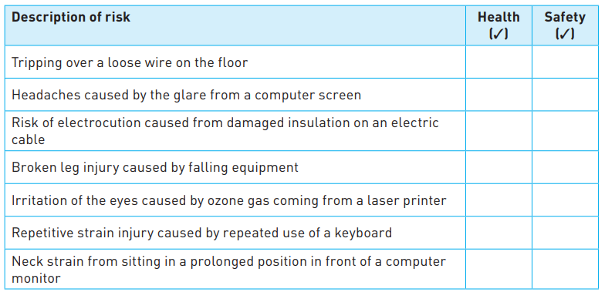



[7]

1. Any one of the following.

» Do not allow drinks to be taken into the computer room

» Check all wires on a regular basis and renew wires if there is any sign of damaged insulation

» Ensure all equipment is checked by a qualified electrician on a regular basis

» Make use of an RCB (residual current breaker) to prevent electrocution [1]