**Quiz 1 (Graded)**

**Safety and security**

1. There are a number of health and safety issues associated with the use of computers. Draw arrows from the terms Health or Safety to the matching issue. Use a maximum of four arrows.

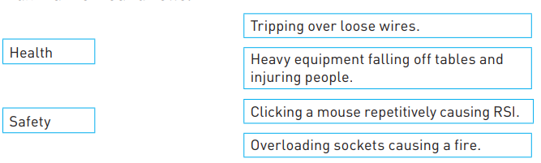

[2]

1. Indicate, by ticking (✓) the appropriate box, which of the following are examples of a health risk and which are examples of a safety risk.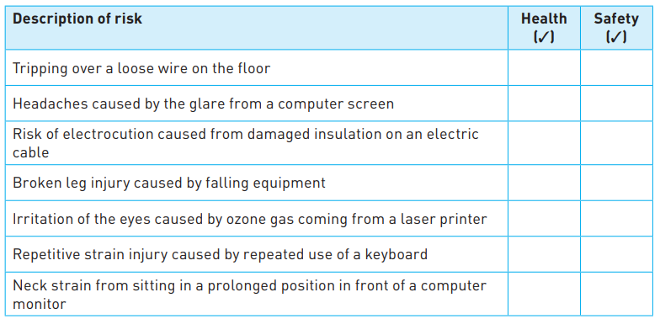

[7]

1. Using computers can cause problems for the health and safety of users. Electrocution is caused by electricity passed through your body. Describe one way to remove or militate against this risk. ………………………………………………………………………………………………………………………………………………………………………………………………………………………………………………………………………………………………………………………………………………………………………………………………………………………………………………………………………………………………………………………………………………………………………………………………………………………………………………………………………………………………………………………………………………………………………………………………………………………………………………………………………………………………………………………………………………………………………………………………………………………………………… [1]