1. **Choose the correct option.** **[3]**
2. 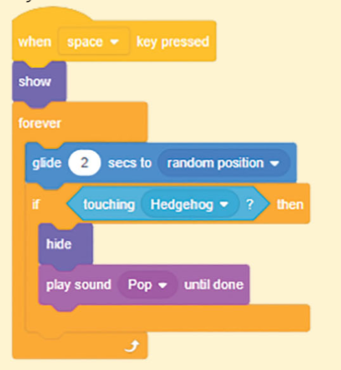In the given code, hedgehog is a **static** object.

(a) True

(b) False

1. 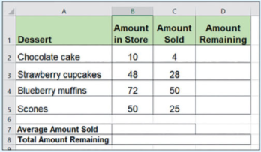Which type of data should be entered in the **Amount Remaining** field be?

(a) Text

(b) Number

(c) Date

1. **If it is raining outside, then I will use an umbrella, otherwise I will not use an umbrella.**

How many conditions are there in above program?  
(a) 1 (b) 2  
(c) 3 (d) None of these

1. 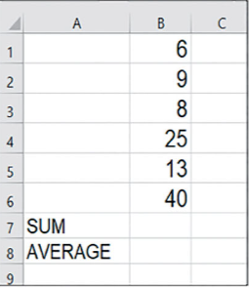**Excel is used to apply many mathematical operators on dataset. [4]**
2. Complete the formula to calculate the sum of all the numbers.

Complete the formula = ________)**B1:**______)

1. Complete the formula to calculate the Average of the numbers.

Complete the formula = ________)**B :**______)

1. 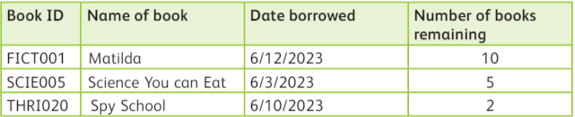**Look at the data in the table. [3]**
2. **Choose the correct data type for each set of data: [1]**
3. Book ID
4. Name of book
5. Date borrowed
6. Number of books remaining
7. **What is the length of the Book ID field**? **[1]**
8. 3
9. 4
10. 7
11. **What would happen if someone tries to enter a Book ID such as MYSTERY012** in the Book ID filed? **[1]**

_______________________________________________________________

1. **Look at the data below and answer the given questions. [5]**

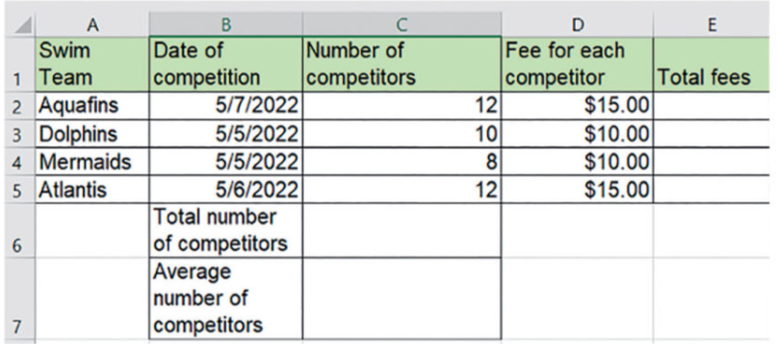

1. **Text can be entered in the number of competitor’s columns**. **[1]**

a) True

b) False

1. **Give a reason for your answer [1]**

______________________________________________________________________________________________________________________________

1. **What is the formula to calculate the total fees paid by Aquafins? [1]**

a) C2+D2

b) C2*D2

c) C2/D2

1. Write down the function to calculate: **[2]**

a) **Total number of competitors:** ____________________________________

b) **Average number of competitors:** _________________________________

1. **Look at the given algorithm and answer the given questions: [5]**

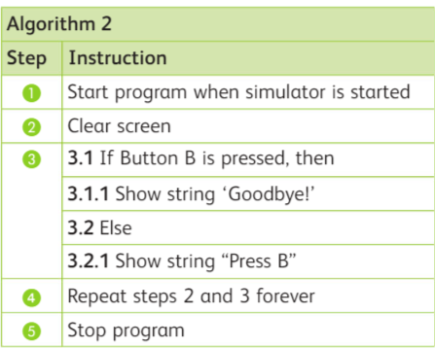

1. What is the input in the program? **[1]**

______________________________________________________________

1. What is the variable in the program? **[1]**

______________________________________________________________

1. What is the condition in the program? **[1]**

______________________________________________________________

1. What is the outcome if the condition is **true? [1]**

______________________________________________________________

1. What is the outcome if the condition is **false? [1]**

______________________________________________________________