Task 1

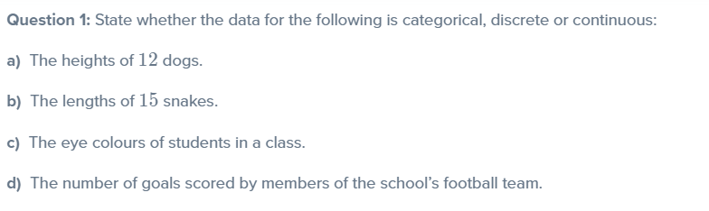

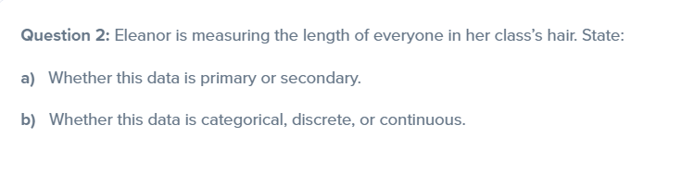

Task 2(Reasoning)

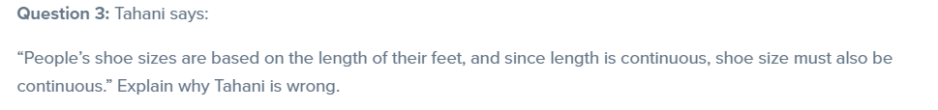

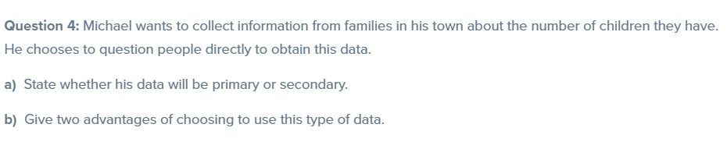Task 3

