**I) Fill in the blanks. [4]**

Online link device internet

a) Google Forms is an _____________ form.

b) To fill out Google Forms you need a _______________,for example a computer.

c) You will also need _______________access and а ________________to the Google Forms template.

**II) The data table shows some data that was collected by Mrs Sara. [4]**

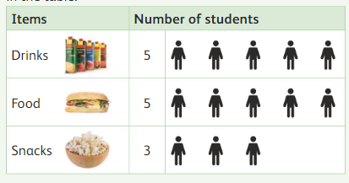

1. How many groups are in the data table? ___________
2. How many students like food? ___________
3. Which is the least popular item? ____________
4. Name your favourite item? ____________

**III. Draw a line to match the type of form with the data to be [5]**

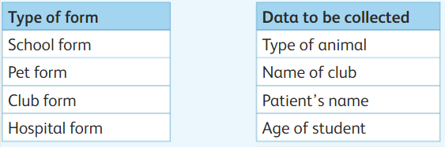 

**IV. Write the missing letter. [2]**

1. D__t__
2. F__r__s