**I) Fill in the blanks. [4]**

Online link device internet

a) Google Forms is_an online form.

b) To fill out Google Forms you need a ___device_______________, for example a computer.

c) You will also need__internet____________ access and а _____link_______to the Google Forms template.

**II) The data table shows some data that was collected by Mrs Sara. [4]**

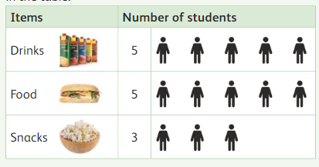

1. How many groups are in the data table? ____3_______
2. How many students like food? ______5_____
3. Which is the least popular item? _____snacks_______
4. Name your favourite item? ____________

**III. Draw a line to match the type of form with the data to be [5]**

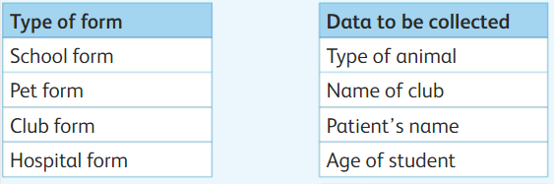 

**IV. Write the missing letter. [2]**

1. D_a_t_a_
2. F_o_r_m_s