1. 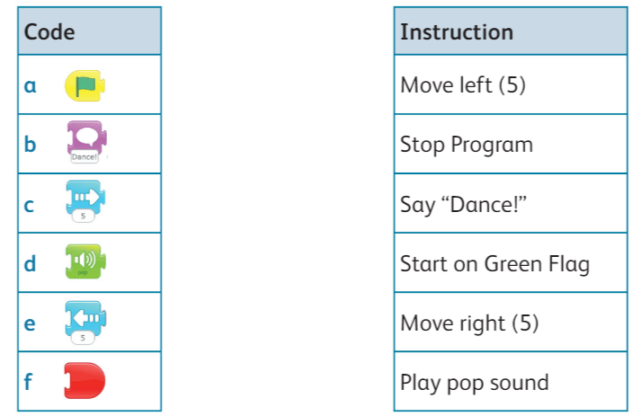Match each block with the instruction [3]
2. Circle the bug in the program below. [3]

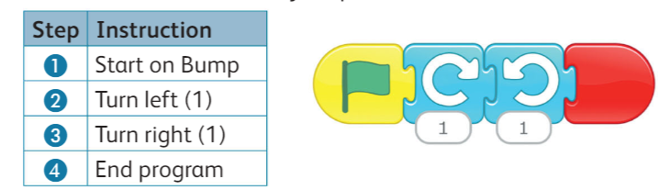

1. Look at the path and fill the algorithm to move a physical object from point 1 to 2

[3]

|  |  |
| --- | --- |
| STEP | Algorithm |
| 1 | Move forward 1 |
| 2 | Turn ________ |
| 3 | Move forward (__) |
| 4 | Turn Right |
| 5 | Move _______ (3) |
| 6 | Turn _______ |
| 7 | move forward (__) |
| 8 | Turn Left |
| 9 | Move forward (__) |

1. Read the statement and answer true or false [4]

* Wireless network is usually found in home. (______)
* Two connected devices cannot do more than standalone device. (______)
* We can share devices on a network. (______)
* Devices can only connect to a network with a wire. (______)

5) which of these devices can connect to a wired network [2]

* 