1. **Choose the correct answer. [5]**

|  |  |  |  |  |
| --- | --- | --- | --- | --- |
| **Hacker** | **Replay** | **Packet sniffing** | **Identity theft** | **Authentication** |

1. When someone steals your personal information and uses it without your permission to commit fraud is called as **Identity theft.**
2. **Hacker** is a person who gains access to the computer system without permission.
3. The process of identifying users that request access to a system, network or device is named as **Authentication**
4. **Packet sniffing** is a piece of software used to monitor network traffic.
5. A **replay** attack is when a hacker intercepts and capture some of sender’s data during online transmission.
6. **Complete the following. [3]**

 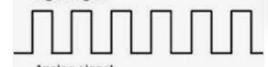

------------------------

Analogue Digital

1. **Match the following. [3]**

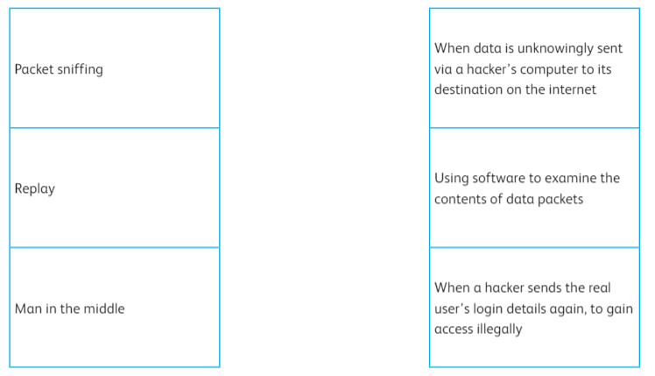

|  |  |  |
| --- | --- | --- |
| **1)** | **2)** | **3)** |
|  |  |  |

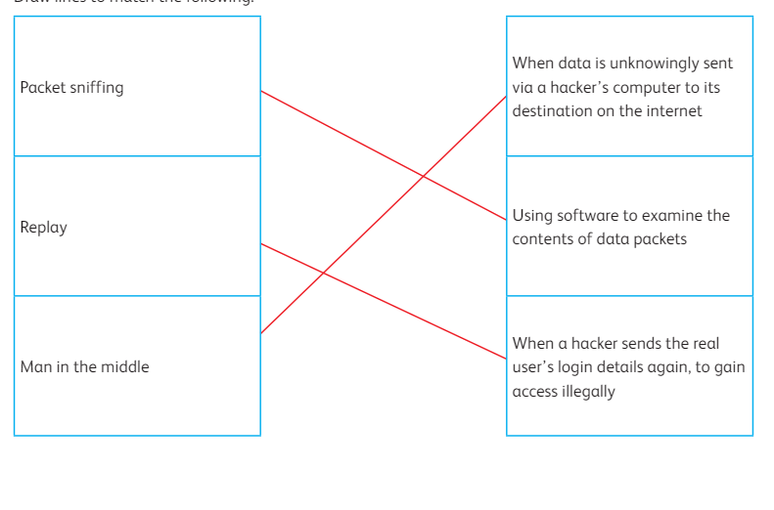

**IV. Answer the following**

1. You are the lead security consultant for a multinational corporation, tasked with enhancing the company's access control system. During a meeting with the executive team, the CEO asks you to explain the concept of "biometric authentication" and provide examples of three types of biometric authentication methods. [6]

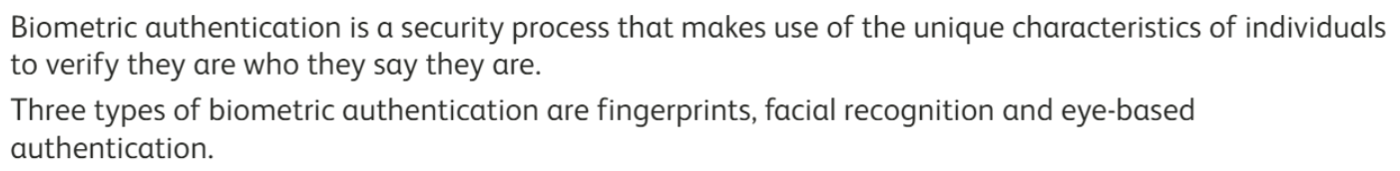

2. You're a cybersecurity specialist conducting a workshop for small business owners on safeguarding their online accounts. One participant asks about the benefits of using strong passwords. How would you explain the advantages of strong passwords to them. [2]



**Protection from Cyberbullying**

3. You're a tech-savvy mentor leading a coding bootcamp for beginners. One of your students, who is new to programming, approaches you during a break and asks for a brief explanation of the two main programming languages. How would you describe these languages to them, considering their limited coding experience and the importance of making the information accessible and understandable?Top of Form

[4]



4. You're a computer science instructor leading a beginner's coding workshop at a local community center. Explain what does syntax mean in programming? Explain why would someone need to learn and use syntax? [2]

