- Answer the following questions: [11]
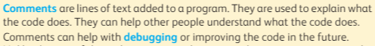
- a. Why do we add comments to the program? [1]
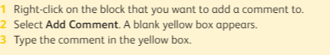
__________________________________________________________________________________________________________________________________________ b. What are the steps of adding a comment? [1]
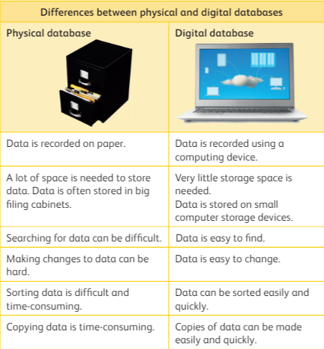
- Mario wants to create a database for a video game. Each record will contain information like name, number of players and game duration. He needs to decide which type of database should he use. Help Mario by writing 4 differences between physical and digital database. [4]

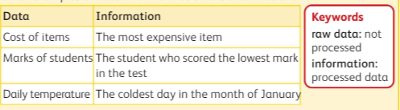
- Differentiate between data and information. [2]
- Jenny wants to know about the favourite book character of her friends. She is thinking of using forms to survey her friends. Jenny is confused whether she should use forms? Help jenny by listing down any three advantages and disadvantages of using forms to collect data. [3]
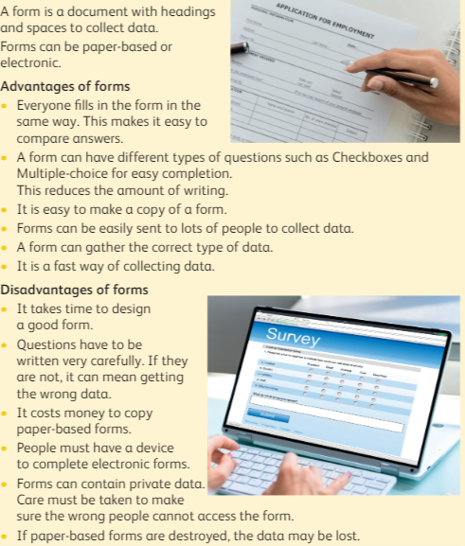

II Choose the correct option. [6]
- ___________________ is used in an animation
(a) repetition (b) algorithm
(c) loops (d) Scratch jr.
- ______________are used in a program to repeat instructions.
(a) Desktop (b) Instructions
(c) Random (d) Loops
- _____________________loop is where the instructions repeat forever.
(a) software (b) event block
(c) loop (d) forever loop
- Forever loop is found under the _____________________ group of blocks.
(a) Event (b) Control
(c) looks (d) pen
- __________________is the process of finding and removing errors from a program.
(a) repetition (b) switching
(c) debugging (d) gliding

- Raw data is ______
(a) Processed (b) Unprocessed
(c) Organised (d) None of these

 | A note explaining the meaning of a program’s code | - Debugging
 | These are used in programmes to repeat instructions | - Repetition
 | the process of finding and removing errors from the program | - Comments
III) Match the following: [3]

