1) Answer the following.

a) ﻿Develop an algorithm that includes repetition for a character in the Chasing Game. In this algorithm, your character should do the following:

1. Start when the Green Flag is clicked.
2. Play a sound called Pop five times at the start.
3. Switch to the next costume five times at the start.
4. Move 10 steps after the last costume switch.
5. Say 'Ha-ha' three times after moving 10 steps.
6. Turn 90 degrees to the left three times after moving 10 steps.

|  |  |
| --- | --- |
| Steps | Instructions |
| 1 |  |
| 2 |  |
| 3 |  |
| 4 |  |
| 5 |  |
| 6 |  |
| 7 |  |
| 8 |  |

b. Explain in your own words which type of loop is used in above algorithm.

________________________________________________________________________

________________________________________________________________________

________________________________________________________________________

________________________________________________________________________

c. Write an algorithm for the below Scratch 3 program.

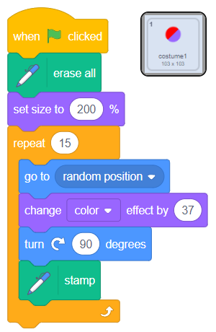

|  |  |
| --- | --- |
| Steps | Instructions |
|  |  |
|  |  |
|  |  |
|  |  |
|  |  |
|  |  |
|  |  |
|  |  |