1. Pick the following and write in the correct column

. Liters Square meters Cubic meters Hectares Acres Cubic meters

Square kilometers Milliliters Cubic centimeters

|  |  |
| --- | --- |
| **Area** | **Volume** |
|  |  |
|  |  |
|  |  |
|  |  |

1. Convert:
2. 0.75 m3 to cm3
3. 4.2 litres to cm3
4. 4000 mm3 to cm3
5. 760 mm2 to cm2
6. Choose the correct answer
7. What is the equivalent of 1 acre in square meters?

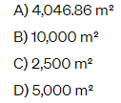

1. How many square centimeters are in 1 square meter?

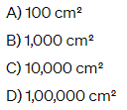

1. If a room measures 5 meters in length, 4 meters in width, and 3 meters in height, what is its volume in cubic meters?

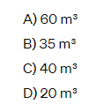

1. What is the volume of a cube with each side measuring 2 meters?

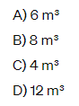

1. A swimming pool has dimensions 12 meters in length, 6 meters in width, and 2 meters in depth. What is the volume of water (in cubic meters) needed to fill the pool?

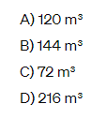

Challenging

1. Chin-Mae has a fi shtank that measures 75 cm by 45 cm by 35 cm. He also has a jug that holds 1.75 litres. He uses the jug to fi ll the fish tank with water. How many full jugs of water does it take to fi ll the fish tank? Show how to check your answer

