Unit 4.1 Human organs

Think like a scientist 2: How many breaths in one minute?

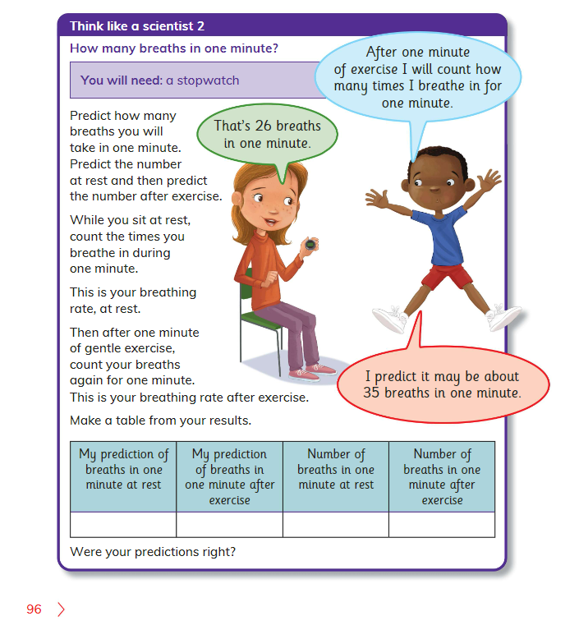

**1. Complete the following table.**

|  |  |  |  |
| --- | --- | --- | --- |
| My prediction of breaths in one minute at rest | My prediction of breaths in one minute after exercise | Number of breaths in one minute at rest | Number of breaths in one minute after exercise |
|  |  |  |  |

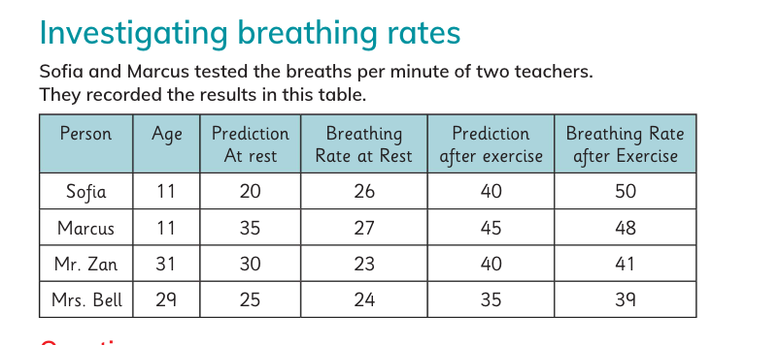

2. Why does the breathing rate per minute always increase after excise?

3. Whose breathing rate per minute increased the most?

___________________________________________________________________________

4. Why was the breathing rate per minute of the adults lower than that of the children?

__________________________________________________________________________

5. Were your predictions, right?

__________________________________________________________________________

**Self-reflection criteria:**

* I can explain where friction happens and what friction does

·      I can measure friction and explain how it is different on rough and smooth surfaces.

·      I can ask a scientific question and plan the right type of scientific enquiry to find the answer.

·      I can choose the best equipment and use it correctly.

·      I can make a conclusion and link it to a scientific question.