**Left, right, clockwise, anti-clockwise turns**

Direction: Use the grid below and follow the directions to answer the questions in the next page.

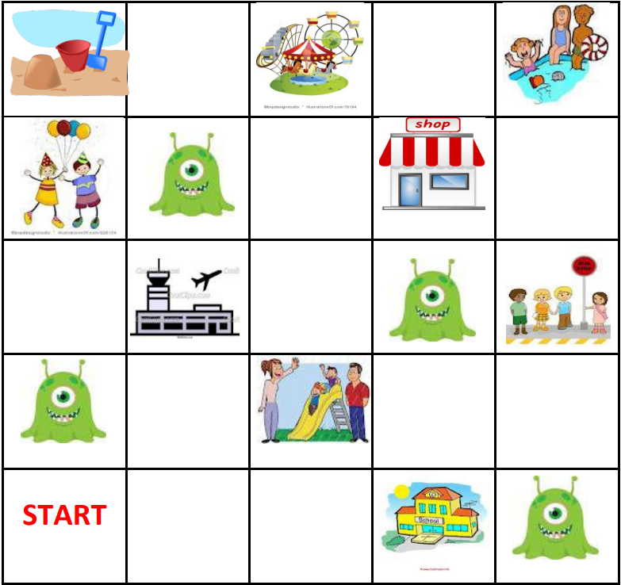

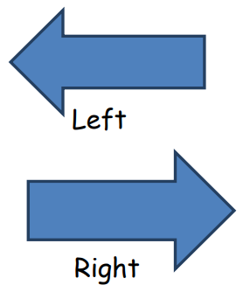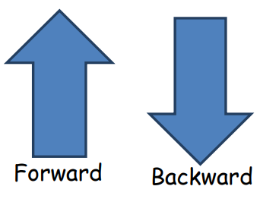

Write your answer.

1. Take 3 steps right. Where are you? _____________________
2. Take 1 step right and 2 steps forward. Where are you? _______________________
3. Take 2 steps right and 1 step forward. Where are you? _______________________
4. Take 2 steps right and 4 steps forward. Where are you? ______________________
5. Take 2 steps right. 3 steps forward and 1 step right. Where are you?

________________________

1. Take 2 steps right, 4 steps forward and 2 steps right. Where are you?

________________________

**Self-reflection**



I can follow and give instructions involving direction and movement including left and right.

I want my teacher to help me in: ___________________________________________