

TERM II

REVISION EXAMINATION

May

2023-2024

Key Stage 3 (Year VIII____)

Date : May 2024

Name of the Candidate : _________________________________________________________

Subject : ICT PRACTICAL

Maximum Marks : 70

Instructions to the candidate:

* The Exam is for 1 hour and 30 minutes.
* Read the instructions carefully.
* Please make sure you have all stationery items.
* Write in dark blue or black pen.
* You may use a soft pencil for any diagrams, graphs or rough working.
* Do not use staples, paper clips, highlighters, glue or correction fluid.
* No marks will be awarded for using brand names of software packages or hardware.
* Answer all questions.
* At the end of the examination, fasten all your work securely together.
* The number of marks is given in brackets [ ] at the end of each question or part question.

|  |  |  |
| --- | --- | --- |
| **Section** | **Maximum Marks** | **Marks Obtained** |
| **Web Authoring** | **56** |  |
| **Data Analysis** | **14** |  |
| **TOTAL** | **70** |  |

Checked by : ____________________________

Rechecked by : ____________________________

**EVIDENCE DOCUMENT**

Create a new word-processed document.

Make sure your name, centre number and student_id will appear on every page of this

document.

Save this Evidence Document in your work area as **j2231evidence_** followed by your centre number_

Student_id, for example, j2231evidence_ZZ999_9999

You will need your Evidence Document during the examination to place screenshots when required.

**Task 1 – WEB AUTHORING**

*You are going to create a web page for Tawara Balloon Safaris. The web page and stylesheet must work in any browser. Make sure that your stylesheet contains no HTML. Make sure your HTML and stylesheet are as efficient as possible.*

1. Create, in your j2231 folder, a web page called tbs.htm

This web page must be created using a single table and must work in all browsers. The table must fit 90% of the width and height of the browser window. The table must have a structure as shown in this diagram:

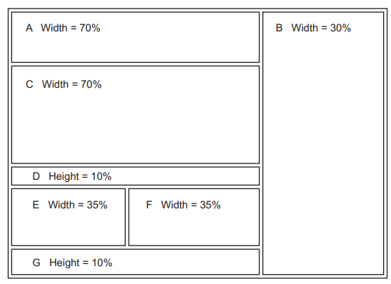

Each table cell is identified with a letter. Some dimensions are shown. These must be set as percentage values. Do not set the height of cells A, B, C, E or F.

The cell contents shown in the diagram must not appear on your final web page.

Table borders must appear on the final web page. [8]

1. Set the title of the web page to Tawara Balloon Safaris
2. Set, in the HTML, the name of the default target window to _new
3. Place in cell:

• A the image j31banner.jpg

• B the balloon image saved in step 1

• C a video tag to display j31balloon.mp4 so that it fits the width of this cell. Display an automated

text based error message if the browser does not support this video type

• E the image j31serengeti.jpg

• F the image j31maasai.jpg [9]

1. Place inline style attributes into the HTML so that each image, with its aspect ratio maintained, fits the width of the table cell. [1]
2. Add appropriate alternate text to all still images.
3. Place in cell D the text from the file j31text.txt Set this text as style h2 [2]
4. Enter in cell G the text:

**Click on the images above to enjoy the wonders of Kenya and Tanzania.**

**Web page last edited by:** followed by a space, your name, centre number and student_id.

Display the text you have entered as two paragraphs.

Set all text in cell G as style h3 [4]

1. Create a hyperlink from the image *j31maasai.jpg* to open the web page **j31kenya.htm** [2]
2. Create a hyperlink from the image *j31serengeti.jpg* to open the web page **j31tanzania.htm** in the browser window that is currently in use. [3]
3. Rename the stylesheet **j31stylesheet.css** to **j31stylesheet_** followed by your centre number_ student id, for example, j31stylesheet_ZZ999_9999

Make sure this stylesheet is still in cascading stylesheet file format.

Attach this stylesheet to your web page.

*A trainee has attempted to create the stylesheet for this website. This file contains a number of errors and omissions. All color codes must be displayed in hexadecimal. Your stylesheet must not contain HTML or scripting language.*

1. Open and edit the stylesheet you saved in step 12 to meet the following specifications:

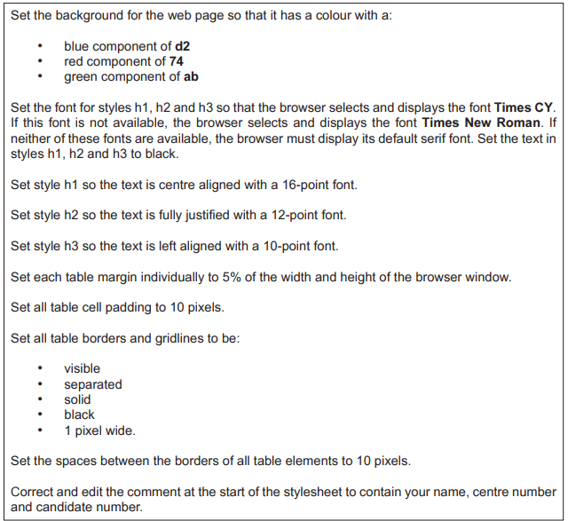

Save this stylesheet in your j2231 folder.

Take a screenshot to show the file name and all contents of your stylesheet and place this in your Evidence Document. Make sure the file name and all contents are clearly visible. [27]

**EVIDENCE 1**

A screenshot of your stylesheet with the required information clearly visible

1. Save your web page.

Display your web page in a browser. If necessary resize it so that:

• all the page can be seen

• all text can be easily read

• the address bar is visible.

Take screenshot evidence showing your web page in the browser. Place this in your Evidence Document.

**EVIDENCE 2**

Screenshot evidence of your web page in the browser with the table contents and background elements clearly visible.

Take a copy of the HTML source and place this in your Evidence Document.

**EVIDENCE 3**

A copy of your HTML source.

[Total: 56]

**Printing the Evidence Document**

Save and print your Evidence Document.

**PRINTOUT 1**

Make sure your name, centre number and student id appear on every page of your Evidence Document.

**Task 2 – DATA ANALYSIS**

*You are going to create a spreadsheet to display data about safety equipment required for a hot air balloon.*

1. Open and examine the file j31tables.csv in a spreadsheet package. This file will be used but must not be edited.

Open and examine the file j31balloon.csv in a spreadsheet package. Save this as a spreadsheet with the filename Balloon_ followed by your centre number_student id, for example, Balloon_ZZ999_9999

Place in the header:

• left aligned, your name, centre number and candidate number

• right aligned, the automated file name with no file path. [2]

1. Enter a formula in cell B5 to look up the equipment item using the item number in cell B4 for the value and the external file j31tables.csv for the array. [5]
2. Enter a formula in cell B7 to display the date and name of the employee who checked the item of safety equipment, using the balloon name, item number and external file j31tables.csv [4]
3. Print your spreadsheet showing the formulae.

Make sure:

• it is in landscape orientation

• the row and column headings are displayed

• the contents of all cells are fully visible. [1]

**PRINTOUT 2**

Make sure that you have entered your name, centre number and candidate number on the spreadsheet showing the formulae

1. Enter into cell B3 the text **Beta**

Enter into cell B4 the number **2**

Save your spreadsheet.

Print the entire spreadsheet showing the values.

Make sure the:

• printout fits on a single page

• contents of all cells are fully visible

• row and column headings are not displayed. [2]

**PRINTOUT 3**

Make sure that you have entered your name, centre number and candidate number on the spreadsheet showing the values.

[Total: 14]