Revision 2

1.

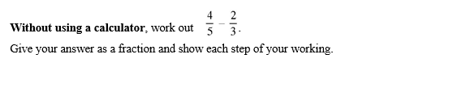

2.



3.

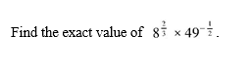

5. Estimate 2.252 x

6.



7.



8. Ahmed owns a company.

(a) Each year he earns $56 000 plus 3% of the year’s proﬁt.

Calculate the amount he earns in a year when the proﬁt is $320 600.

(b) In the following year the proﬁt is $347 851.

Calculate the percentage increase in the proﬁt.

9.

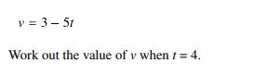

10.

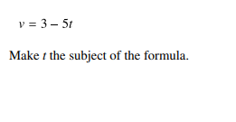

11.

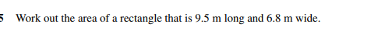

12.

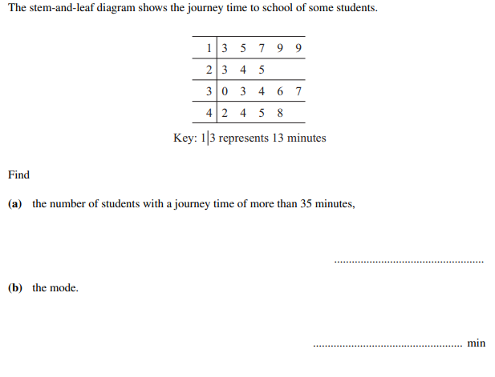

13.

14.

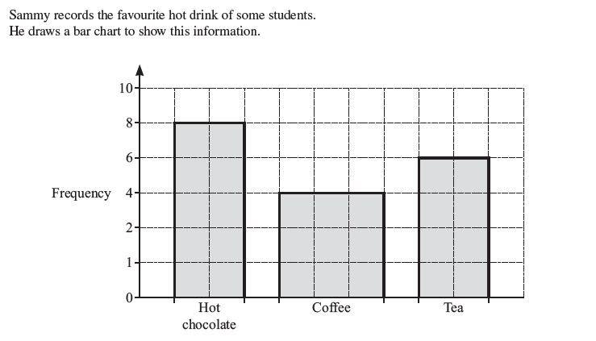

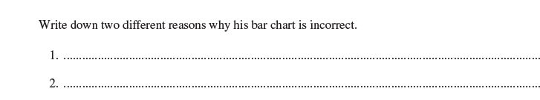

15. Evaluate and give your answer to 2 dp.

- )2

16. Write in standard form

(7 x 10-21) ÷(1 x 1016)

17. Simplify +5 -