**Revision**

**Marketing mix: product**

**Starter activity:**

Match the following terms with their definitions:

|  |
| --- |
| 1. Marketing mix |
| 1. Product |
| 1. Brand |
| 1. unique selling point |
| 1. Brand image |
| 1. brand name |
| 1. brand loyalty |
| 1. Product life cycle |
| 1. extension strategies |

|  |
| --- |
| 1. when customers continue to purchase from the same brand over and over again, despite competitors offering similar products or services. |
| 1. general impression, perception, and associations any given customer has about a brand. |
| 1. a combination of factors that can be controlled by a company to influence consumers to purchase its products. |
| 1. identifies a specific company, product, or service and differentiates it from similar brands within a category |
| 1. a type of product manufactured by a particular company under a particular name. |
| 1. a practice used to increase the market share for a given product or service and thus keep it in the maturity phase of the marketing product lifecycle rather than going into decline. |
| 1. the length of time from a product first being introduced to consumers until it is removed from the market. |
| 1. an article or substance that is manufactured or refined for sale. |
| 1. a marketing statement that differentiates a product or brand from its competitors |

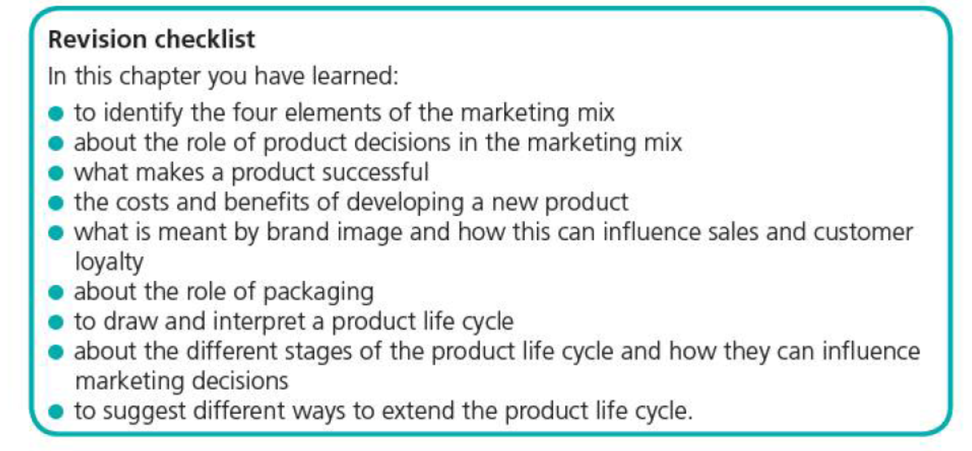

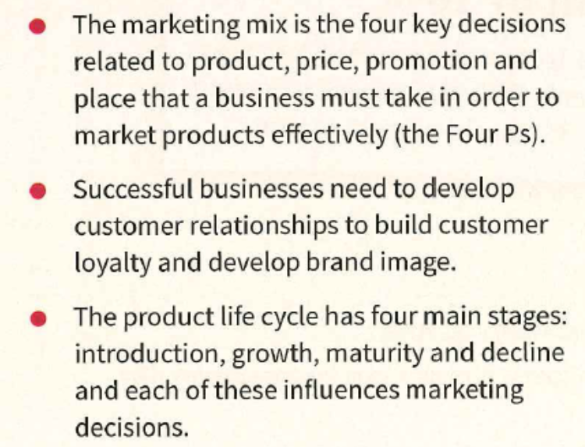

**Development activity:**























