The marketing mix: product
Total Time: 25-30 min
Total marks: 15 marks
- Deﬁne ‘marketing mix’.
..................................................................................................................................................................
..................................................................................................................................................................
..................................................................................................................................................................
.................................................................................................................................................................. [2]
2. Deﬁne ‘customer loyalty’.
..................................................................................................................................................................
..................................................................................................................................................................
..................................................................................................................................................................
.................................................................................................................................................................. [2]
- Deﬁne ‘brand image’.
..................................................................................................................................................................
..................................................................................................................................................................
..................................................................................................................................................................
.................................................................................................................................................................. [2]

4. |  | MTD manufactures specialist cleaning products including soap. Batch production is used. The business uses  just-in-time inventory control. MTD took 18 months to develop its latest environmentally friendly cleaning  product. The Marketing Manager has to decide on the packaging and method of promotion for this new  product. She said: ‘All our stakeholders, including pressure groups, are important. MTD wants to contribute  to sustainable development.’
Outline two factors MTD should consider when deciding on the packaging for its new product.
Factor 1: ...................................................................................................................................................
..................................................................................................................................................................
..................................................................................................................................................................
..................................................................................................................................................................
Factor 2: ...................................................................................................................................................
..................................................................................................................................................................
..................................................................................................................................................................
.................................................................................................................................................................. [4]

5. |  | RVC uses batch production to manufacture a large range of products including soap and shampoo. Many of the products are at different stages of the product life cycle. The Marketing Director has been reviewing some data for one brand of soap, as shown in the Table. She said: ‘Last year sales were 80 000 units a week. I want to know the current level of proﬁt and margin of safety.’ The Marketing Director has to decide on a suitable extension strategy. The choice is between new packaging or targeting new markets.

Table:
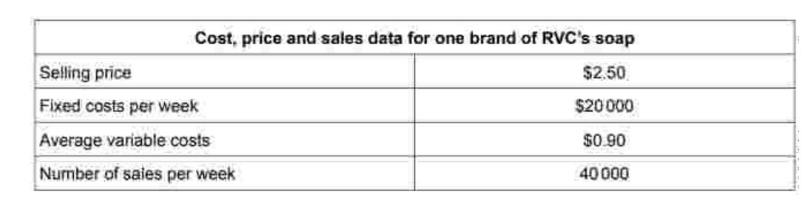Do you think targeting new markets is a better extension strategy than new packaging for a manufacturing
business? Justify your answer.
..................................................................................................................................................................
..................................................................................................................................................................
..................................................................................................................................................................
..................................................................................................................................................................
..................................................................................................................................................................
..................................................................................................................................................................
..................................................................................................................................................................
..................................................................................................................................................................
..................................................................................................................................................................
..................................................................................................................................................................
..................................................................................................................................................................
.................................................................................................................................................................. [5]

