***SEARCHING FOR DATA USING A FILTER***

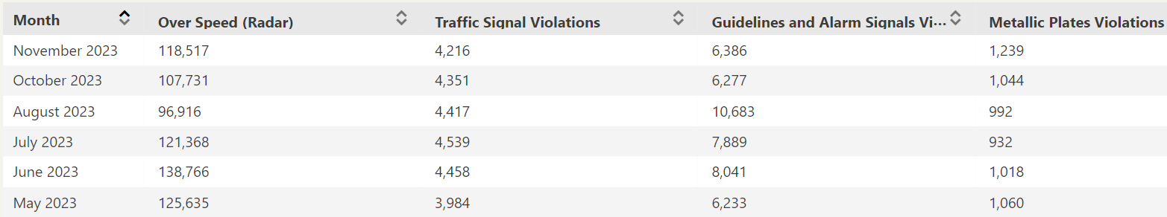

Above data shows the traffic violations for the past 6 months in Qatar.

Insert the above data in spreadsheet

Use a filter to find records with dataset that meet the following criteria.

1. Month: August 2023
2. Over speed: Lesson than 1000
3. Traffic signal violations: Less than 1500
4. Guidelines and alarm signals: More than 6000
5. Metallic plate violations: More than 1000

When applying above filter on the given data set, take Screen shot and

Paste it in MS Word Document.

Save MS word document by your name.