**1. True or false?**

1 True or?

a A data table is used to

group data.

b Grouping data makes it

hard to understand.

c We can answer questions

using a data table.

2 Work in pairs.

The data table shows

favourite ice-creams.

a How many ice-cream

flavours are in the data table?

b Say the names of the groups.

a. A data table is used to group data.

1 True or?

a A data table is used to

group data.

b Grouping data makes it

hard to understand.

c We can answer questions

using a data table.

2 Work in pairs.

The data table shows

favourite ice-creams.

a How many ice-cream

flavours are in the data table?

b Say the names of the groups.

b. Grouping data makes it hard to understand.

1 True or?

a A data table is used to

group data.

b Grouping data makes it

hard to understand.

c We can answer questions

using a data table.

2 Work in pairs.

The data table shows

favourite ice-creams.

a How many ice-cream

flavours are in the data table?

b Say the names of the groups.

c. We can answer questions using a data table.

**2. The data table shows favourite ice-creams.**

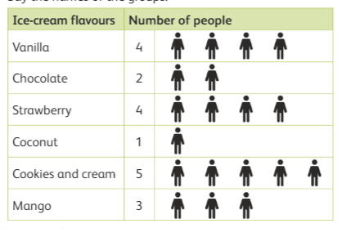

1. How many ice-cream flavours are in the data table?_____________
2. Which is the least popular ice-cream? ______________
3. Which is the most popular ice-cream? ______________