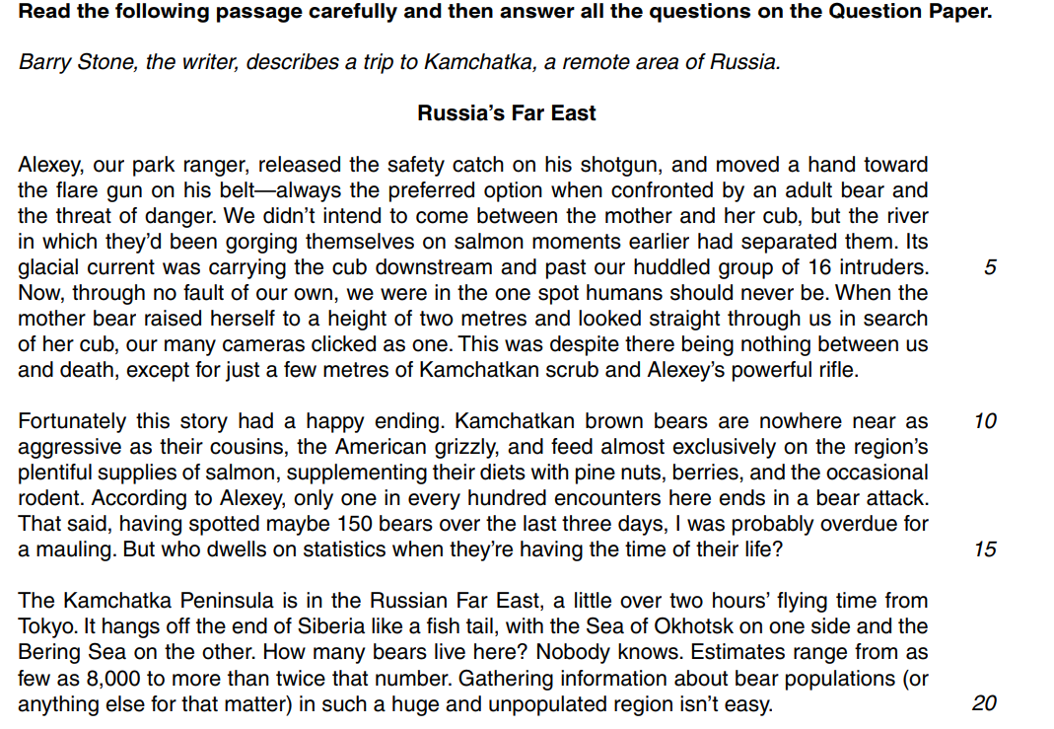
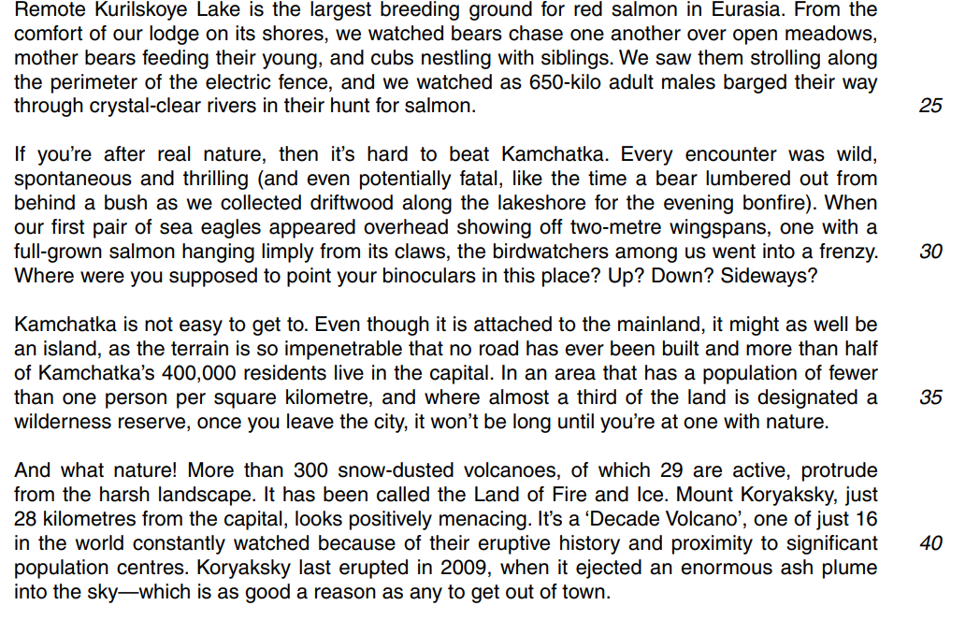

Read carefully the passage Russia’s Far East in the Reading Booklet Insert, and then answer all the questions on this Question Paper.

Question 1

- From paragraph one (Alexey, our park ranger…), give two reasons why the writer and his companions were in danger from the bear.

  - ...............................................................................................................................................

.................................................................................................................................................

  - ...............................................................................................................................................

..............................................................................................................................................
[2]

- What is surprising about the way that the ‘intruders’ reacted when the mother bear stared straight at them (line 5)?

.................................................................................................................................................

.................................................................................................................................................

.................................................................................................................................................

...............................................................................................................................................
[2]

- Why is it difficult to gather information about the size of the bear population in Kamchatka (paragraph three: The Kamchatka Peninsula…)?

.................................................................................................................................................

...............................................................................................................................................
[1]

- Using your own words, explain the reactions of the birdwatchers when they saw the sea eagles (paragraph five: If you’re after…).

.................................................................................................................................................

.................................................................................................................................................

.................................................................................................................................................

...............................................................................................................................................
[2]

- (i) Give one fact about Mount Koryaksky from the final paragraph.

.......................................................................................................................................[1]

(ii) What is suggested by the word ‘Decade’ in line 39?

...........................................................................................................................................

.......................................................................................................................................[1]

- By referring to the whole passage, give two ways in which the ranger and the visitors are protected against bears.

  - ...............................................................................................................................................

  - .............................................................................................................................................

  - [2]

- Using your own words, explain what the writer means by the words in italics in the following phrases:

- ‘I was probably overdue for a mauling ’ (lines 14–15)

...........................................................................................................................................

.......................................................................................................................................[2]

- ‘the terrain is so impenetrable ’ (line 33)

...........................................................................................................................................

.......................................................................................................................................[2]

- ‘looks positively menacing ’ (line 39)

...........................................................................................................................................

.......................................................................................................................................[2]

- Re-read paragraphs one to five (Alexey, our park ranger… to …Sideways?).

The writer uses the following phrases to describe the behaviour of the bears.

Choose three of the following phrases and then explain how each one of them helps you to gain an impression of the bears’ behaviour:

  - ‘gorging themselves on salmon’ (line 4)
  - ‘strolling along the perimeter’ (lines 23–24)
  - ‘barged their way through crystal-clear rivers’ (lines 24–25)
  - ‘lumbered out from behind a bush’ (lines 27–28).

Phrase: .................................................................................................

Explanation: ...........................................................................................................................

...........................................................................................................................

......................................................................................................................................................................................................................................................
[2]
Phrase: .................................................................................................
Explanation: ...........................................................................................................................

...........................................................................................................................

......................................................................................................................................................................................................................................................
[2]
Phrase: .................................................................................................
Explanation: ...........................................................................................................................

..........................................................................................................................

..........................................................................................................................
[2]

