Quiz 2 Marking Scheme
Data Representation

Question | Description | Marks
1 a) | 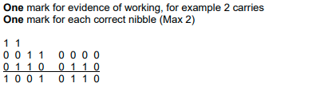 | 3
1 b) | Hexadecimal | 1
1 c) | One mark for suitable working method e.g. flip and add 1 One mark for correct answer − 10011101 | 2
1 d) | One mark for each correct nibble (max 2)  One mark for correct working e.g. correct carry  One mark for showing overflow bit  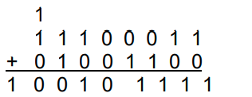 | 4

