**Quiz 2**

**Topic: Data Representation**

1 a)

b)

c)

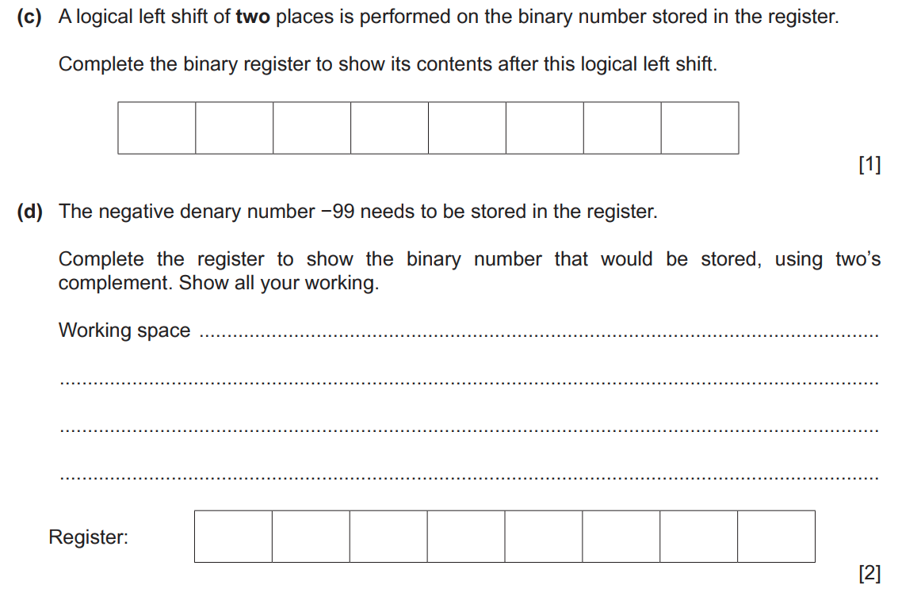

d)

