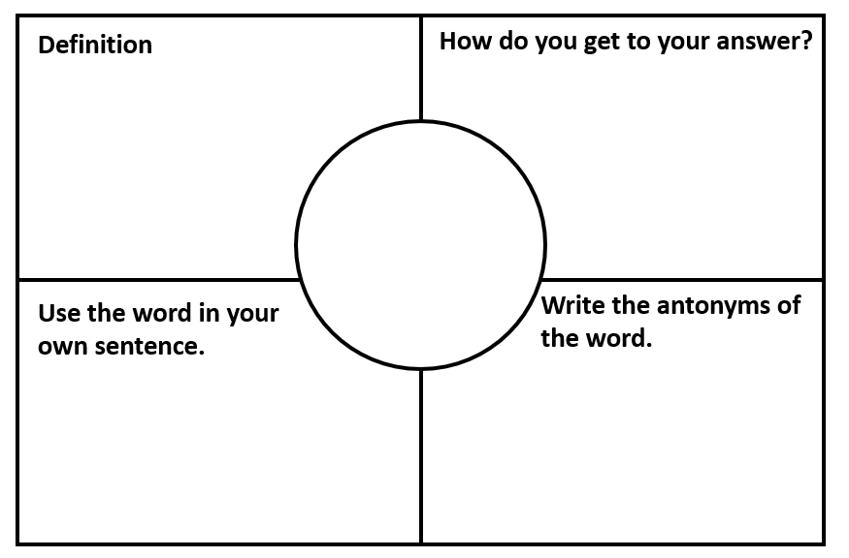

**Write the synonyms of the word.**

**awkward**



**Write the synonyms of the word.**

**relevant**



**Write the synonyms of the word.**

**sufficient**



**Write the synonyms of the word.**

**ancient**



**Write the synonyms of the word.**

**miserable**



**Write the synonyms of the word.**

**convenient**



**Write the synonyms of the word.**

**inadequate**



**Write the synonyms of the word.**

**peaceful**



**Write the synonyms of the word.**

**coward**



**Write the synonyms of the word.**

**visible**