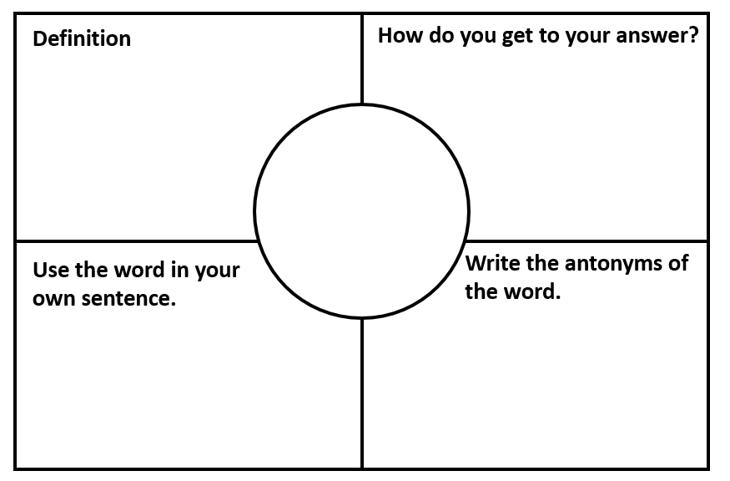

**Write the synonyms of the word.**

**legal**



**Write the synonyms of the word.**

**advantage**



**Write the synonyms of the word.**

**wise**



**Write the synonyms of the word.**

**impolite**



**Write the synonyms of the word.**

**equal**



**Write the synonyms of the word.**

**possible**



**Write the synonyms of the word.**

**honest**



**Write the synonyms of the word.**

**agree**



**Write the synonyms of the word.**

**trust**



**Write the synonyms of the word.**

**visible**