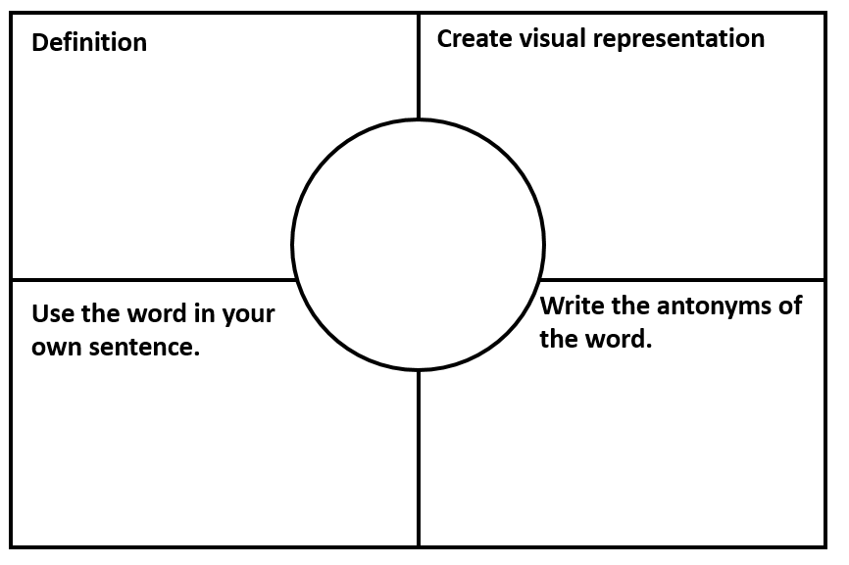

**Write the synonyms of the word.**

**young**

**young**



**Write the synonyms of the word.**

**rich**



**Write the synonyms of the word.**

**wise**



**Write the synonyms of the word.**

**foolish**



**Write the synonyms of the word.**

**fantasy**



**Write the synonyms of the word.**

**silence**



**Write the synonyms of the word.**

**narrow**



**Write the synonyms of the word.**

**interesting**



**Write the synonyms of the word.**

**scare**



**Write the synonyms of the word.**

**abundant**