1. Write true or false next to each sentence and rewrite the false ones.
2. Friction always acts in the opposite direction to the moving object.

____________________________________________________________________________

1. Friction always speeds up a moving object.

____________________________________________________________________________

1. Smooth surfaces create more friction than rough surface

____________________________________________________________________________

1. Lift is an upward force that a liquid applies to objects.

___________________________________________________________________________

1. Air resistance is a type of friction caused by air pushing against any moving object.

___________________________________________________________________________

1. **Circle the object that would fall faster.**

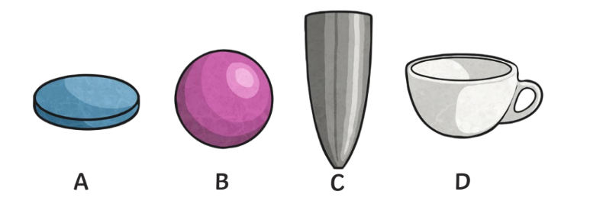

Explain your answer.

________________________________________________________________________________

________________________________________________________________________________

________________________________________________________________________________

1. **Select the correct word from each bracket to complete the sentences.**
2. The Moon has a ___________ (smaller/ greater) mass than Earth so the gravitational pull on the Moon is ___________ (smaller/ greater) than it is on Earth.
3. Jupiter has a ____________ (smaller/ greater) mass than Earth so the gravitational pull on Jupiter is _____________ (smaller/ greater) than it is on Earth.
4. The Earth’s gravitational pull is the pull that Earth exerts on an _________ (object/ nobody), pulling it towards Earth’s ___________ (edge/ centre). It is the Earth’s gravitational pull which keeps us on the ___________ (ground/ sky).
5. **Write the name of the force in action next to each arrow.**

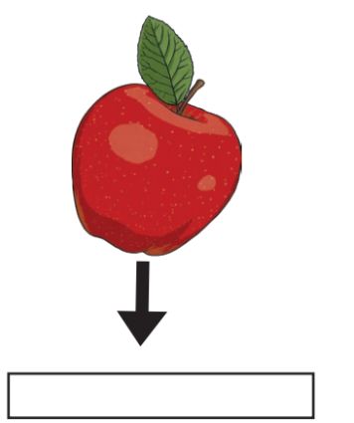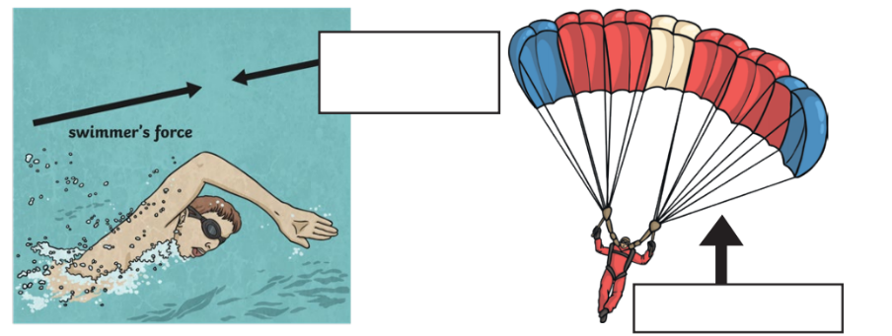

1. **Draw a line to match the word to its definition.**

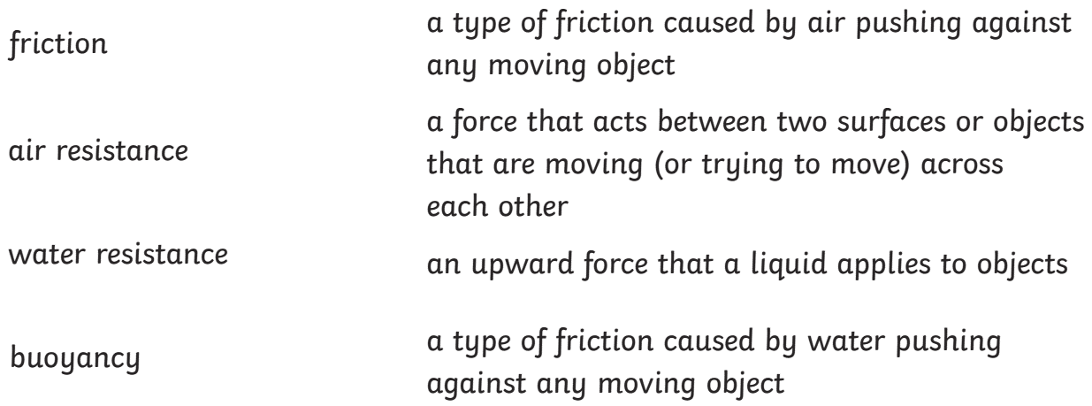

Upthrust/

1. Give one example for each when friction is helpful and when friction is having a disadvantage.

____________________________________________________________________________________________________________________________________________________________________________________________________________________________________________________________________________________________________________________________________

1. A satellite is created by a human being what is it called and why do we need those satellites?

_____________________________________________________________________________________________________________________________________________________________________________________________________________________________________________________________________________________________________________________________________________________________________________________________________________________

1. Label the forces on this Kayak. Use the letters next to each phrase.

