**Revision worksheet chapter 1 & 2**

1. (a) Tick whether the following are examples of System software or Applications software.

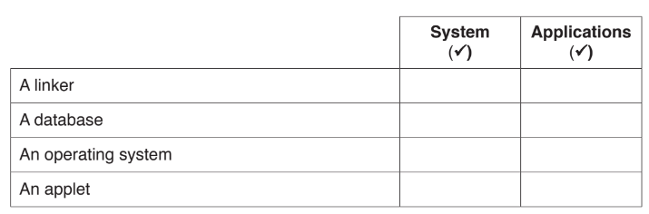

[2]

(b) Tick whether the following are examples of Internal hardware or External hardware.

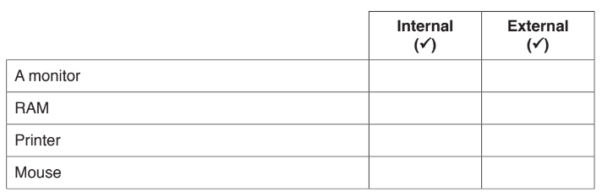

[2]

1. Complete the following sentences about input and output devices, using items from the list below.



1. An output device that is used to produce hard copy architectural drawings is a

................................................................................................................................................... [1]

1. An input device that is used in a virtual reality system is a

................................................................................................................................................... [1]

1. The inbuilt input device on a laptop is a

................................................................................................................................................... [1]

1. An output device that is designed to output music is a

................................................................................................................................................... [1]

1. A smartphone has many uses, for example making and receiving telephone calls.

Give four other uses of a smartphone.

1……………………………………………………………………………………………………………...

2……………………………………………………………………………………………………………...

3……………………………………………………………………………………………………………...

4…………………………………………………………………………………………………………..[4]

1. Tick whether the following statements are true or false.

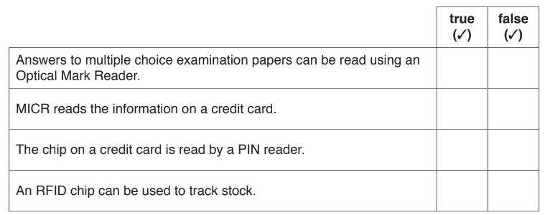

[2]

1. Tick whether the following statements relate to a command line interface (CLI) or a graphical user interface (GUI).

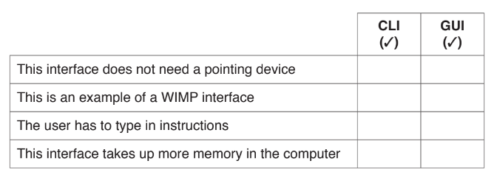 [2]