1a  b | 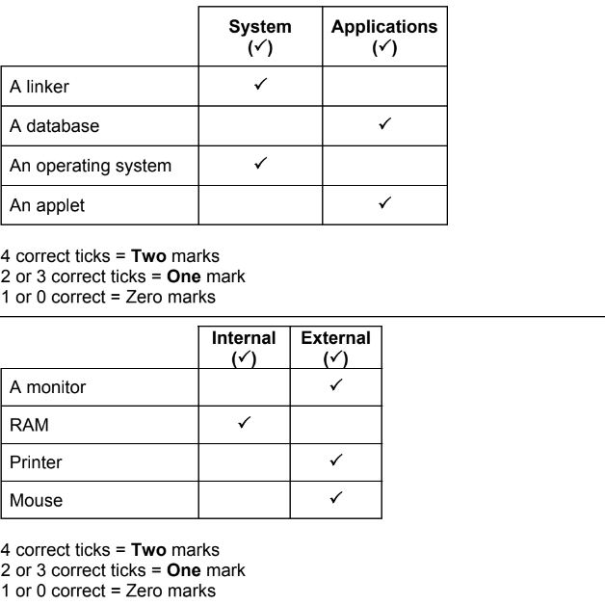 | 2  2
2a  B  C  d | 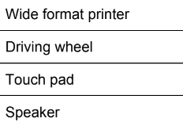 | 1  1  1  1
3 | Four from, for example:  GPS/location services/sat nav  Telephone banking  Social networking  Emails sending/receiving  Streaming videos/music  Making/receiving text messaging  Taking photos  Play music | 4
4 | 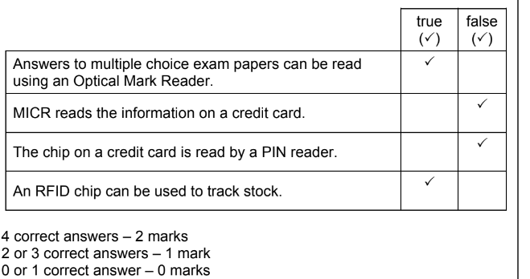 | 2
5 | 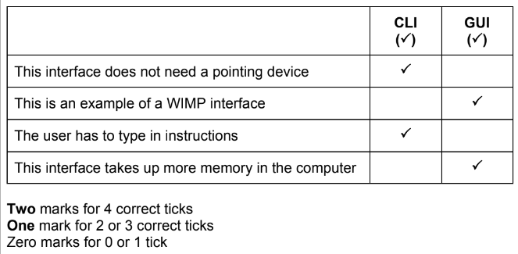 | 2

