Formal Formative 3



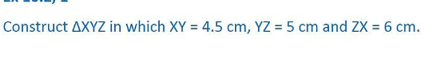

2.

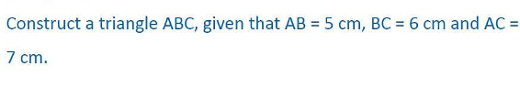

3.

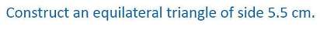

4.

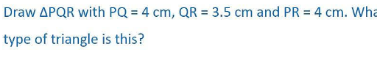

5.

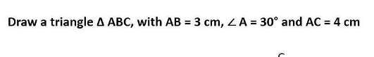

6.

